Vanderbilt University Language Development Lab
PSYCHOLOGY AND HUMAN DEVELOPMENT
302 Jesup Psychology Building
(615) 343-8721

SUMMARY:
THE PARKING LOT FOR STUDY PARTICIPANTS IS LOCATED AT HORTON AVENUE AND 18TH AVENUE SOUTH. THERE ARE RESERVED PARKING SPACES FOR STUDY PARTICIPANTS IN THE ON-CAMPUS PARKING LOT. (THESE SPACES ARE NOT IN THE LARGE PARKING LOT ACROSS 18TH AVE- THEY ARE ON CAMPUS.)

- TURN INTO LOT: IN PARKING AREA, SPOTS ARE TO THE RIGHT MARKED “FOR RESEARCH PARTICIPANTS ONLY” (HEAD-IN PARKING).
- SOMEONE FROM OUR LAB WILL MEET YOU IN THE PARKING LOT TO WALK YOU OVER TO OUR BUILDING.

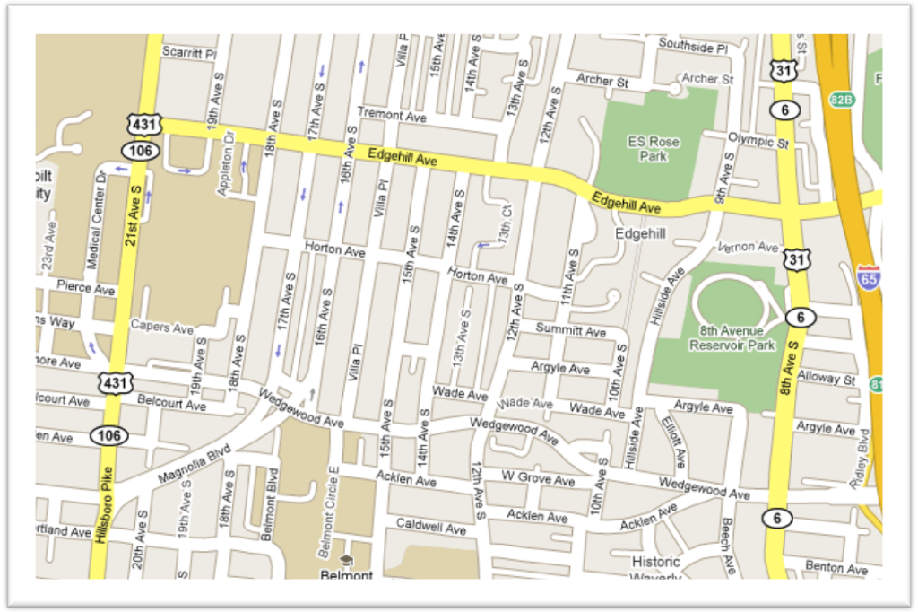

DETAILED DIRECTIONS:
West End Ave.
I-40
Wedgewood
12th Ave
21st Ave
I-65
Edgehill
Horton
18th Ave
19th Ave

FROM SOUTH OF NASHVILLE ON I-65N:
Exit at Wedgewood Avenue- Exit 81.
Turn left onto Wedgewood and go about 1 mile to 18th Avenue and turn right.
Go straight and turn left into parking lot when you reach Horton Ave.

FROM EAST OF NASHVILLE ON I-40W:
Exit at Broadway, Exit 209A.
Turn left onto Broadway and go 1.3 miles (staying to the left at the Broadway/West End split and merging onto 21st Avenue).
Get in the left turn lane before you get to the footbridge.
Before the footbridge, turn left onto Edgehill Avenue. Take Edgehill Avenue to 18th Avenue and make a right onto 18th Avenue.
On 18th Avenue, turn right into parking lot at Horton Avenue.

FROM WEST OF NASHVILLE TAKING I-40E OR FROM I-440 CONNECTOR:
Take I-40 East towards Nashville.
Merge onto I-440 East via Exit 206.
Exit I-440 at Hillsboro Road/21st Avenue, Exit 3.
Merge onto 21st Avenue. Proceed up 21st Avenue for about 1 mile. At the Blakemore/Wedgewood intersection, turn right onto Wedgewood Avenue and get into left lane.
Make a left onto 18th Avenue South. Go straight and then turn left into parking lot when you reach Horton Avenue.

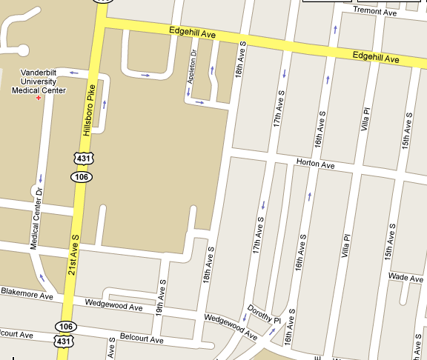
We will be waiting for you in the parking lot upon your arrival with a parking pass.
Please call (615) 343-8721 if there is anything with can assist you with. Thank you!

