|  |
| --- |
| **Vanderbilt University** |
| Mech. Engineering Techniques and Best Practices Manual |
| Guidelines for quality and efficient handwork |

|  |
| --- |
| Tom Withrow and Alex Pedchenko |

Contents

Soldering 3

Definition: 3

Resources: 3

Quick tips: 3

Drilling 5

Definition: 5

Resources: 5

Quick Tips: 5

Cutting Speed Selection Guide 7

Sawing 8

Definition: 8

Resources: 8

Quick Tips: 8

Hand Saw Type Selection Guide 8

Hacksaw 9

Band Saw 10

Using a Rotary Tool (“Dremeling”) 12

Definition: 12

Resources: 12

Quick Tips: 12

Rotary Tool Bit Selection Guide 13

Rotary Tool Cutting Speeds 15

Tapping and Threading 16

Definition: 16

Resources: 16

Quick Tips: 16

Imperial Drill & Tap Chart 17

Metric Drill & Tap Chart 18

Proper Use of Adhesives 19

Definition: 19

Resources: 19

Quick Tips: 19

Adhesive Selection Guide 19

Laser Cutting Prerequisites 21

Requirements: 21

Preparing files to cut: 21

Future Sections 22

Rapid Prototyping/Additive Layer Manufacturing 22

Working with Materials: 22

Working with Circuits 22

Microcontroller Basics 22

Tiny AVR – can program in Arduino 22

# Soldering

Definition:

Soldering is a process in which two or more metal items are joined together by melting and flowing a filler metal (solder) into the joint, the filler metal having a lower melting point than the adjoining metal. Soldering differs from welding in that soldering does not involve melting the work pieces. [wikipedia]

## Resources:

**THIS IS A MUST WATCH BEFORE YOU BEGIN:**

1. <https://www.youtube.com/watch?v=BLfXXRfRIzY> [colderstart user youtube]

Very basic soldering guide. Less than 5 min.

1. <https://www.youtube.com/watch?v=J5Sb21qbpEQ> [EEVblog youtube channel]

<https://www.youtube.com/watch?v=fYz5nIHH0iY> [EEVblog youtube channel]

<https://www.youtube.com/watch?v=b9FC9fAlfQE> [EEVblog youtube channel]

A 3 part quite in-depth tutorial. 1st link is dedicated to soldering tools. 2nd link is soldering through hole components to PCB boards. 3rd link is soldering surface mount components. Quite detailed and is a great source if you’ll be doing a lot of solder work or are interested in creating your own circuit boards.

1. The Art of Electronics by Paul Horowitz and Winfield Hill

Not a book on soldering, but instead a very thorough guide on electronic components and the functions they serve in circuits. Widely recognized as *the* reference on electronic circuits. Great for learning as well as a very useful reference. As a side note, at the time this is written, this book is highly recommended in the graduate level mechatronics class.

## Quick tips:

1. Always tin (touch the solder to the iron’s tip such that it flows onto it and coats it) your iron before heating the components you want to solder as this will DRASTICALLY improve the heat transfer and therefore solder flow.
2. Use a **WET** sponge instead of the flick method to remove excess solder. That being said, still use safety goggles.
3. When possible, make use of a third hand. Keeping the work pieces that are to be joined stationary and in direct physical contact to each other makes the job much easier.

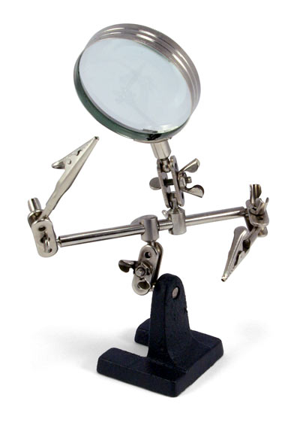

Third hand

1. Ensure there is a good physical connection between the wires/components prior to soldering
2. Avoid touching the soldering iron with the solder once it is tinned- Use the iron to heat the wire and then melt the solder on to the heated joint.
3. Try not to breath in solder fumes by working in a well-ventilated area or by working next to a fan. Even if the solder is lead-free (which, as a side note, tends to be more difficult to work with), the fumes may be hazardous to your health and prolonged exposure should be avoided.
4. Always wash your hands after soldering.
5. When soldering small components or metal that's close to plastic (e.g., leads of a linear potentiometer, operational amplifiers), don't hold the iron on the component you are soldering for too long or you may damage the component. Use the coolest setting on the iron that will melt the solder for better results (660 °F or 350 °C is good for most general purpose soldering, 750 °F or 400 °C should be used for large components and heat sinks, higher temperature should be reserved only for lead-free soldering with large components and rework).
6. You can always test the quality of your joints by using your multimeter's continuity mode. The figure below shows the symbol to which you should set your multimeter. When you touch the probes together, you should hear a beep indicating a sound electrical connection. When you join two conductive paths using solder, you can check whether current can run freely through the newly formed connection by placing the probes at the two location of your circuit which you now expect to be electrically joined.

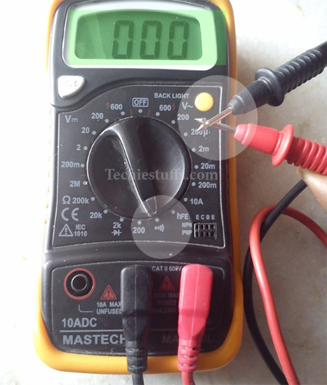

Multimeter in continuity mode with probes touching

(you should hear a continuous beep as long as the probes are in contact)

1. Soldering is **not** used to make mechanical connections. Solder should not be viewed as glue and will not join parts in such a way that the join can be stressed. **Use it only to make electrical connections**.
2. Never try to use a soldering iron to melt or cut plastic. NEVER. It will just ruin the soldering iron.

# Drilling

Definition:

A cutting process that uses a drill bit to cut or enlarge a hole of (almost always) circular cross-section in solid materials. The drill bit is a rotary cutting tool, often multipoint. The bit is pressed against the workpiece and rotated at rates from hundreds to thousands of revolutions per minute. This forces the cutting edge against the workpiece, cutting off chips (swarf) from the hole as it is drilled. [wikipedia].

## Resources:

1. Machining Fundamentals by John R. Walker. The Goodheart-Willcox Company Inc., 2004. Tinley Park, Illinois. p.153-182. Wide overview of drill and drill machine types, clamping devices, basic safety, different drilling operations and good practices.
2. Shop Reference for Students and Apprentices 2nd ed. compiled by Edward G. Hoffman. Industrial press Inc., 2000. New York. p. 361-369. Quick tips on drilling. Large collection of recommended cutting speeds for different materials.
3. <https://www.youtube.com/watch?v=zqtO3NnixwQ> [doitbestcorp user youtube] Basic guide on hand-held drills, tools, and techniques. < 4 min.
4. <https://www.youtube.com/watch?v=VBSAqU8aunI> [Ray LeBel user youtube] < 1 min video on what peck drilling looks like.
5. <https://www.youtube.com/watch?v=6JyIR5nwRho> [Kenneth Finnegan user youtube] 16 min video covering the basics of using a drill press. Numerous tools for drilling operations are shown and discussed. **NOTE:** This fine gentleman, despite being knowledgeable in the use of a drill press, decided to hold his work piece. This is NOT something you should EVER do, so -20 pts for him, and please don’t follow this bad example. Use a c-clamp or a vise.

## Quick Tips:

1. As with all machining, always wear safety goggles and secure/tuck-in loose clothing, jewelry, long hair, or anything else that can get caught in the spindle.
2. Use a center punch and center finder before drilling to ensure accurate hole placement. If even more accuracy is desired, consider using a mill with digital position readout in conjunction with an edge finder.
3. Always clamp the work piece solidly using a vise or a set of solid c-clamps (several is better). Never hold the work piece with your hand. A properly held work piece should not move
4. Parallels are often used in conjunction with a vise to level your work piece and lift it off the vise base to drill through holes (see picture on next page).
5. Always check the drill diameter before drilling a hole using either calipers or a micrometer. New drills are checked across the drill margins (i.e., largest diameter of the fluted section of the drill), worn drills are checked on the shank at the end of the flutes.
6. Remember to always remove the key from the chuck before turning the drill on.

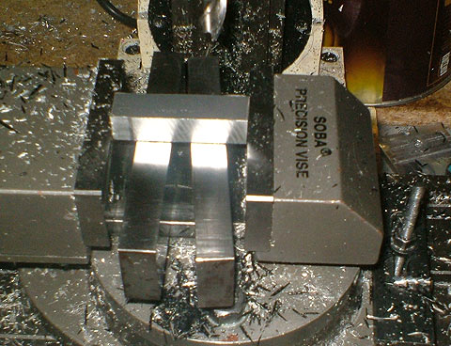

Vise

Parallels

Work piece

1. Check that the drill runs true after tightening it in the chuck. Drill bits get warped during improper use and may not be able to make good straight holes.

1. To locate your initial hole location after using a center punch, use a center drill to begin the drilling process.
2. If drilling a hole larger than 0.25” start with at least a 0.25” drill bit or a similar sharp drill bit about that size.
3. Cutting fluid **should** **always** be used in steel and Aluminum. Cutting fluid prolongs drill bit life while simultaneously making the drilling operation easier by reducing friction at the cutting edges and improving hole finish. Use a cutting fluid whenever possible **EXCEPT** when drilling cast iron or other brittle materials. When working with those types of materials, use compressed air intermittently. Always thoroughly wash your hands after using cutting lubricants and read the warning on the container to know what to do should some get in your eye.
4. Use the correct cutting speed for the material you are working on. Speeds that are too slow or too high decrease tool life and increase chance of drill bit breakage (which, if you don’t care so much about drill bits that are not your own, can, and most likely will, destroy your work piece). For the correct cutting speed for your specific material, check the Resource 2 (Shop Reference…) in the section above. Here is a rough guideline for cutting speeds for common materials:

RPM for cutting operation = $\frac{12 ×speed from table (feet/min)}{3.14 ×diameter of drill bit (inches)}$

### Cutting Speed Selection Guide

|  |  |
| --- | --- |
| **Material** | **Cutting speed using a high-speed steel cutter (feet/min)** |
| Plain carbon steel | 40-50 |
| Alloy steel | 40 |
| Cast steel | 55 (down to 30 for higher carbon content) |
| Stainless steel | 40 |
| Wrought and cast aluminum alloys | 350 |
| Brass | 160 |
| Gray cast iron | 60-100 |
| Malleable iron | 45 |

1. A dull drill bit will squeak and overheat. Also, watch for blue, rough chips and drill press slow down as signs of a dull drill bit.
2. When removing a drill from a drill press, place a piece of wood not far below it. Small drills can be damaged if dropped and larger ones can cause injury.
3. Clean chips off using a brush instead of your hands. Splinters are not pleasant, independent of constituent material.
4. Use peck drilling to drill small diameter holes. Drill in 0.25” increments, letting the drill bit completely emerge from the work piece between each ‘peck’, completing the hole through incremental cutting (see Resources (4) video). This will help clear the chips from the hole, which can otherwise cause the drill bit to get jammed and break. You can also apply cutting fluid intermittently during peck drilling to aid the drilling operation, cool the drill bit, and increase its lifetime.
5. Never rapidly cool drill bits by plunging them into water. The shock of sudden cooling can crack them.

# Sawing

Definition:

A material cutting process that uses a blade with a series of teeth on its edge to cut a narrow opening in a workpiece. Sawing may be used to produce slots or grooves or to separate the workpiece into two pieces. [http://www.toolingu.com/]

## Resources:

1. <https://www.youtube.com/watch?v=AcA-ReT3EHA> [Toms Techniques user youtube] Excellent 6 min safety video on band saw use. Definitely watch this if you’re just starting to use this machine or if you need a refresher. Also shows how to safely cut round stock on a vertical band saw.
2. <https://www.youtube.com/watch?v=ZYlLIp5urJQ> [IUSculpture's channel user youtube] Great 10 min video demonstrating the versatility of the band saw and some best practices. **NOTE:** The user does have his hands a little too close to the blade, AVOID doing this. Use a push stick or clamp your work piece with a vise grip to distance your hands from the fast-traveling, serrated metal band of destruction.

## Quick Tips:

1. Never test the sharpness of any saw by running your finger along the teeth. Find a small scrap piece of material or visually inspect the teeth.
2. Always wear safety goggles with all saws. Even a hacksaw blade can shatter and produce flying metal shrapnel.
3. Choose the correct saw for the job. Here are some common types:

### Hand Saw Type Selection Guide

|  |  |
| --- | --- |
| **Saw Type** | **Material** |
| Crosscut saws and ripsaws  http://www.blogcdn.com/www.diylife.com/media/2010/03/ripsaw-590ks030410.jpg http://www.blogcdn.com/www.diylife.com/media/2010/03/crosscut-saw-590ks030410.jpg | Wood |
| Keyhole saw  http://www.buyezrip.com/drywall-tips/KeyholeSaw.gif http://www.northwaysmachinery.com/images/products/detailview/NICHOLSON%20NSP9W.jpg | Wood, drywall |

|  |  |
| --- | --- |
| **Saw Type** | **Material** |
| Coping saw  http://upload.wikimedia.org/wikipedia/commons/2/2d/Coping_saw_2.jpg | Wood (contoured or smooth line cuts) |
| Hacksaw  http://previewcf.turbosquid.com/Preview/2014/05/23__00_06_06/Hack_Saw.jpgF7BF5FF7-B582-4E9C-ADE66D796C2F26B8.jpgLarger.jpg https://www.macbuildingproducts.com/images/14SAWHACHBAH268.gif | Metal and plastic |

### Hacksaw

1. When mounting a new hacksaw blade, make sure the teeth are facing away from the handle such that the saw cuts on its forward motion.

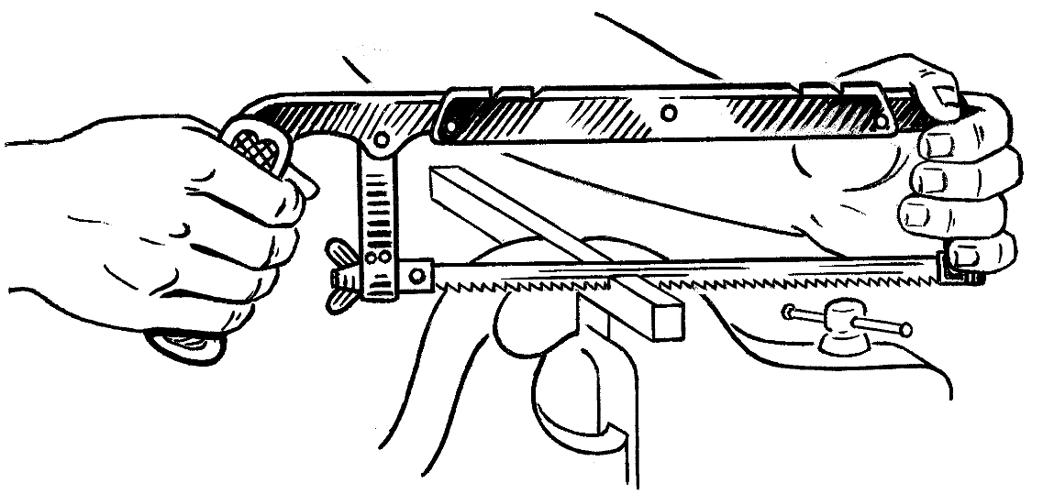

Hacksaw (note the blade teeth orientation and the proximity of the cut to the vise)

1. A hacksaw blade should “ping” when snapped with your finger. Frequently a blade must be retightened after the first few strokes as it will stretch slightly from the head produced while cutting.
2. Use a vise or a c-clamp to tightly secure your work piece and cut as close to the vise/c-clamp as practically possible to limit chatter.
3. The first cut should be started on a flat side as opposed to a corner or edge. It is also good practice to notch the work with a file.

1. Hold the hacksaw by the handle and the front of the frame. Apply enough pressure on the forward stroke and lift the saw slightly on the return stroke. Cut with the full length of the blade.
2. If you break or dull a hacksaw blade, do not continue with a new blade in the same cut as the new blade will often bind and be ruined. Rotate the work and start the cut on the opposing side.
3. When the blade has almost cut through the work, saw carefully and support the piece being cut off with your free hand.

1. For mild materials and hard steels, use coarse blades with plenty of chip clearance. For tubing, angle iron and sheet metal work use fine pitched blades. 2-3 teeth should be in contact/cutting at all times.
2. Cutting long narrow strips from thin metal can be done by setting the blade at a right angle to the frame as shown below. Also, thin metal can be cut more easily and precisely by sandwiching it between two pieces of wood and cutting through both wood and metal.

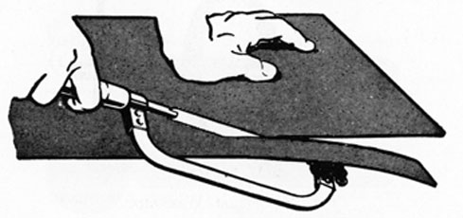

### Band Saw

1. If you’re installing a new band saw blade, wear heavy leather gloves.
2. Adjust the band saw guides to be about 1/4”-1/2” above the piece that you’re going to cut. Make sure that the piece can clear under the guides along its cutting path.
3. Lubricate the band saw blade on both sides to increase tool life and reduce noise while cutting. Carefully (with your hands out of the blade’s path, and the stick on the band saw table) holding a wax stick up to a running blade is a common method for lubrication but cutting fluid can also be used.
4. Use a push stick or vise grip to make sure your fingers are **never** in the path of the blade behind your work piece.
5. Be careful cutting round stock or any work piece that tends to rotate. Special precautions need to be made, watch Resource # 1 (Toms Techniques) to see how this can be done safely.
6. When cutting a long piece/creating a long cut, be weary that the blade can be “pinched” by the recently cut region as material is removed. This can be addressed by applying a gentle pulling force on both side of the cut BEHIND the running blade. Ask someone to assist you as opposed to reaching around the blade.

# Using a Rotary Tool (“Dremeling”)

## Definition:

A rotary tool is a hand held power tool with a variety of rotating accessory bits and attachments that can be used for cutting, carving, sanding, polishing and many other applications.

The smaller rotary tools use high RPMs to maintain the correct cutting conditions for the tool bits. They have low torque which makes them safer for freehand use than the larger higher powered models or similar power tools. A wide variety of accessories are available for applications such as cutting, carving, sanding, polishing, and grinding. The carving (or cutting) bits are referred to as burrs and are similar to those used by dentists.

Rotary tools are sometimes called "Dremels" because of the market strength of Dremel, a particular brand. But the Dremel name is still protected and is far from legally genericized. [wikipedia]

## Resources:

1. <https://www.youtube.com/watch?v=7pL-2LaLyUM> [Engineering Lab Safety user youtube] A quick (less than 4 min) overview of basic rotary tool safety. Brief examples of grinding jobs.
2. <http://www.dremel.com/en-us/videosandhowto/Pages/default.aspx> [official Dremel website] A plethora of DIY videos for all sorts of projects involving cutting, sanding, engraving, grinding, etc., etc., Most videos are quite short.

## Quick Tips:

1. Many rotary tool jobs produce a large amount of debris and, when cutting hardened metals, sparking is not uncommon. Therefore, rotary tools should be operated while wearing both, safety goggles and adequate gloves (for working with hard metals, thick fabric which won’t limit your dexterity is preferred).
2. Never position your hand such that if the rotary tool slips, your hand is along its cutting/grinding plane.
3. Always, always, make sure that whatever you are using a rotary tool on is very securely clamped.
4. 3 common rotary tool grips:

THE PENCIL GRIP

This grip offers the best control for fine detail work. Use this only once you got comfortable with the tool and if you’re engraving a very soft material (such as a pumpkin) at low speeds.

http://www.dremel.com/en-ca/customerservice/productsupport/gettingstarted/PublishingImages/gettingStarted_grip1.gif

Pencil Grip

THE PARING KNIFE GRIP

Use this grip with cutters when making longer, smoother cuts. This grip offers good control for cutting depth. This grip is probably used most often. Remember that even though a rotary tool has relatively low torque, if the spinning bit seizes up in/on the work piece, you’ll have very little time to react, which may lead to all sorts of injuries. Remember to always use a light touch with a rotary tool. You’re just guiding the tool. Let the high speed do all the work.

http://www.dremel.com/en-ca/customerservice/productsupport/gettingstarted/PublishingImages/gettingStarted_grip2.gif

Paring Knife Grip

THE GOLF GRIP

One and two hands. When you want to keep the tool parallel to the work surface for sanding or grinding, use the one-handed grip. Use the two-handed grip every time you use a cut-off wheel. Cut-off wheels can stick and cause kickback. Two hands offer better control. However, just as with the paring grip, don’t apply too much force towards the workpiece, and instead, let the high RPM do the work.

http://www.dremel.com/en-us/customerservice/productsupport/gettingstarted/PublishingImages/gettingStarted_grip3.gif

Golf Grip

1. Common rotary tool bits and their uses:

### Rotary Tool Bit Selection Guide

|  |  |  |
| --- | --- | --- |
| **Attachment** | **Use** | **Material** |
| Diamond bits  Diamond Dremel bits | Carving and engraving | Metals  Bookboard  Ceramic tile  Glass  Mirror |
| High-speed cutters  Dremel high speed cutters | Carving and engraving | Bookboard  Linoleum  Polymer clay  Wood |

|  |  |  |
| --- | --- | --- |
| **Attachment** | **Use** | **Material** |
| Sanding bands and drums  Dremel sanding bands and drum | Sanding | Metals  Bookboard  Plexiglass  Polymer clay  Wood |
| Abrasive cutting wheels  Dremel cut-off wheels | Cutting | Mostly metals  Wood  Plastic |
| Fiberglass cutting wheels  http://mdm.boschwebservices.com/files/r52007v15.jpg | Cutting | Metals including hardened steel  Ideal for shortening fasteners and  making slots in stripped ones |
| Aluminum oxide grinding tools  Dremel grinding stones | Grinding | Metals  Castings  Welded joints  Rivets  Rust  General purpose |
| Aluminum oxide grinding tools (higher grade)  http://tech.bareasschoppers.com/wp-content/image_gallery/tech/electrical/ground_fix/grinding_stones.jpg | Grinding | Use on harder steels than the orange tools above |

|  |  |  |
| --- | --- | --- |
| **Attachment** | **Use** | **Material** |
| Polishing felt, mandrel, and compound  Dremel felt polishersDremel polishing compound | Cleaning and polishing | Aluminum  Ceramic tile  Glass  Mirror |
| Carbon steel brushes  http://mdm.boschwebservices.com/files/r19801v15.jpg | Polishing  Removing rust and corrosion  Cleaning electrical components | Pewter  Aluminum  Stainless steel |

1. Recommended cutting speeds for cut-off wheels:

### Rotary Tool Cutting Speeds

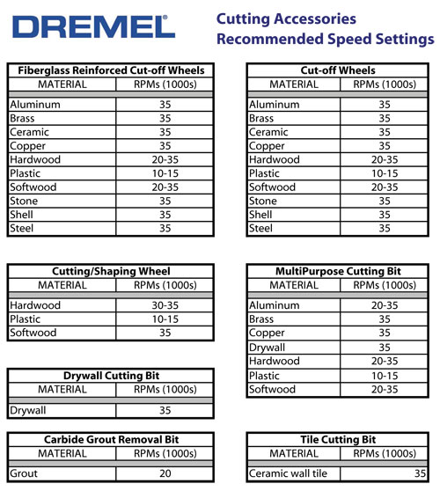

# Tapping and Threading

## Definition:

Taps and dies are cutting tools used to create screw threads, which is called threading. A tap is used to cut the female portion of the mating pair (e.g., a nut). A die is used to cut the male portion of the mating pair (e.g., a bolt). The process of cutting threads using a tap is called tapping, whereas the process using a die is called threading. Both tools can be used to clean up a thread, which is called chasing. [wikipedia]

## Resources:

1. <https://www.youtube.com/watch?v=KVnN4jiB7Gk> [youtube user NewMetalworker] < 4 min video introduction to tapping and threading. Best starting place if you have never used a tap or a die.
2. <https://www.youtube.com/watch?v=gVcwjjBAT4Q> [youtube user diplocraterion] < 3 min Small demonstration of using a die to cut external threads. Good introduction, not the best quality video, but the British accent will keep you entertained.
3. <https://www.youtube.com/watch?v=0MyzdVGQXkg> [youtube user Ultimate Handyman] < 4 min video on tapping threads using a drill. Advanced technique that should be used only if you’re comfortably with tapping by hand.

## Quick Tips:

1. The first step in creating a well-tapped hole for a fastener is to create a well-drilled, correctly-sized hole to work with. Refer to the section on drilling for proper technique.
2. Refer to the thread/screw drill & tap charts for both imperial and metric fasteners (p.17-18) to make sure the drilled hole is of the correct diameter. As a simple, quick check, ensure that your chosen drill’s diameter is smaller than the diameter of the fastener for which you’ll be tapping.
3. Using tapping fluid (or cutting fluid, e.g., Tap Magic) makes tapping MUCH easier in metals.
4. When you start tapping your hole, after the first couple of threads are cut, make sure to follow the one turn forward, half a turn back technique shown in Resources 1 (NewMetalworker video). If you feel the tap is straining quite a bit during the cutting motion, reduce the forward motion to half a turn. DO NOT forcibly turn taps that are providing quite a bit of resistance as it is unfortunately quite easy to break them. You can easily destroy the tool as well as your work piece.
5. When using a die to cut the external thread, it is necessary to chamfer the round stock on all sides such that the die can engage the stock easily as shown below.

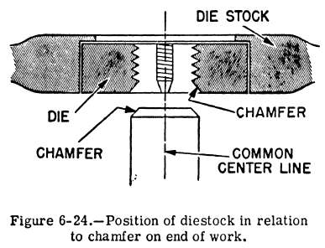

The chamfer helps the die engage the round stock

to start the external thread cutting

1. Use the technique of going a turn forward and half a turn back when cutting external thread with a die as shown in Resources 2 (diplocraterion video)

### Imperial Drill & Tap Chart



### Metric Drill & Tap Chart



# Proper Use of Adhesives

## Definition:

An adhesive is any substance applied to the surfaces of materials that binds them together and resists separation. Adjectives may be used in conjunction with the word “adhesive” to describe properties based on the substance's physical or chemical form, the type of materials joined, or conditions under which it is applied. The use of adhesives offers many advantages over binding techniques such as sewing, mechanical fastening, thermal bonding, etc. These include the ability to bind different materials together, to distribute stress more efficiently across the joint, the cost effectiveness of an easily mechanized process, an improvement in aesthetic design, and increased design flexibility. Disadvantages of adhesive use include decreased stability at high temperatures, relative weakness in bonding large objects with a small bonding surface area, and greater difficulty in separating objects during testing. [wikipedia]

## Resources:

1. <https://www.youtube.com/watch?v=3eh0u2FDzwQ> [youtube user ubcengphysprojectlab] ~ 1 min video introduction to using epoxy. Very brief and basic, but an excellent introduction.

## Quick Tips:

1. Use of safety goggles and gloves are strongly encouraged. Many adhesives are chemically dangerous compounds that can cause serious problems with physical exposure.
2. Some adhesives give off toxic fumes. Make sure to read the warning label and work in either a well-ventilated area or use a respirator.
3. Selecting the right adhesive for the job is the first step in a achieving a good quality bond. Here is a rough guide to choosing the proper adhesive for the job. Remember, reading the directions/description of suitable materials on the specific adhesive itself is a better way of ensuring a good bond.

### Adhesive Selection Guide

|  |  |  |  |
| --- | --- | --- | --- |
| **Adhesive** | **Material candidates** | **Bond strength** | **Drying Time/Curing Time**  **Notes** |
| PVA (polyvinyl acetate, e.g., Elmer’s) | Plastic, paper, fabric, styrofoam, organic materials | Weak | Dries in 1 hr, Cures in 24 hrs. Hold in place for first 30 min. |
| Wood glue (e.g., Titebond Wood Glue) | Wood (surprise) | Strong | Dries in 1 hr. Cures in 24 hrs. Good clamping for first 30 min. Coat both surfaces to be joined. |
| Cyanoacrylates (super glue, e.g., Krazy Glue) | Metals, glass, ceramics, plastics, organic materials | Strong | Often dries in < 5 min. Cures in 24 hrs. Apply to both surfaces to be joined. |
| Silicone adhesives (e.g., Permatex RTV Silicone) | Plastics, ceramics, glass, metals. | Weak to moderate | Sets in ~ 5 min, dries in 1 hr. Cures in 24 hrs. Flexible, waterproof bonds. |
| Epoxies (e.g., Loctite Epoxy) | Plastics, ceramics, wood, glass, metals (J.B. Weld is a good choice), organic materials. | Strong | Setting and drying times vary greatly, check directions. Usually cures in 24-48 hrs. |

|  |  |  |  |
| --- | --- | --- | --- |
| **Adhesive** | **Material candidates** | **Bond strength** | **Drying Time/Curing Time**  **Notes** |
| Hot glue (used with hot glue gun) | All except metals. Usually a better candidate exists. | Weak | Sets in about 15-30 sec, dries in 5-10 min. Cures in 24 hrs. Usually used in crafts and does not provide structurally sound bonding. |
| Expandable glue (polyurethane adhesives e.g., Gorilla Glue) | Mostly used on wood. Can also work on plastics, glass, ceramics, metals, and organic materials. | Strong | Dries in 1-2 hrs. Cures in 24 hrs. Often water-activated, so surface needs to be slightly moistened. Expands, filling cracks but possibly seeping out of originally intended bonding area. Make sure to use tight clamping. |

1. Always clean and prep the surfaces you want to join. Remove dust, debris, grease, oil, moisture (unless glue calls for wet surfaces) and/or oxide film from the surfaces which are to be joined. Poor surface preparation is one of the most common reasons for bond failure. Use the following as a guideline:
   1. Clean the surface from any dust, dirt, any loose particulates. If you use a detergent, make sure to use plenty of water to ensure no amount of it remains after the cleaning process.
   2. Use acetone or isopropyl alcohol to degrease the surface. Although the surface may appear clean, even oil from your fingerprints can undermine the strength of your bond. (**Note:** when adhering plastics, be aware that acetone and isopropyl alcohol may damage certain types of plastics. Make sure you check the plastic’s chemical compatibility chart before using either of these substances on it.)
   3. For best bonds/those that require plenty of strength, abrading the surfaces is highly recommended. Not only does this make the surfaces even cleaner, but it also increases the surface area over which the adhesive will be able to grip. Use fine grain (120-200) sand paper, steel wool, emery cloth, or grit blasting. Remember to repeat steps a. and b. from above after finishing as abrading will create particles and may introduce dirt.
2. Improper clamping is another common reason for poor bond strength. Make sure to use c-clamps when possible to apply a good amount of pressure between the two pieces that are being joined as the adhesive cures.
3. Be patient. Just because the pieces are holding together does not mean the bond has achieved its full strength. Check the directions as to how long you should wait to ensure the bond is as strong as it will get.

# Laser Cutting Prerequisites

## Requirements:

If you wish to use the Featheringill senior design Full Spectrum Laser laser cutter, be aware of the following:

1. Before preparing a file and purchasing your material, ensure that the intended material is suitable for cutting. The Full Spectrum Laser Start-up Guide (one copy is located next to the Full Spectrum Laser laser cutter and another one can be found in the Design Studio) includes a table of materials that can and cannot be cut. This guide also includes step-by-step instructions on how to op
2. You will need to ask a trained person to do the laser cutting for you. You are **not** permitted to use the laser cutter by yourself unless you have received the appropriate training and have the explicit permission of Tom Withrow.
3. You will need to provide your own material to cut. Some good sources for basic materials are Lowes and Home Depot for plywood and MDF and McMaster-Carr (<http://www.mcmaster.com/>) for plastics, rubbers, foams, fabrics, etc.,
4. You will need to prepare your files ahead of time and have them on a USB flash drive (see next section to see how files are prepared). The computer controlling the laser cutter does **not** have internet access, therefore you will **not** be able to simply email the files to yourself.

## Preparing files to cut:

Note: This is not the only way to prepare a laser cutting job, but is the most common. The use of Creo/CAD software is encouraged to prep your file as you can use assemblies to ensure your laser cut parts are to scale/the size you need for interaction with other components.

1. Create the piece(s) that you wish to cut out as an extrusion using your choice of CAD software. Remember that the laser cutter can cut only 2D pieces. The thickness of your extrusion does not matter as the thickness of the material you will be cutting will determine the height of the cut piece. However, it would be wise to set the extrusion height to the thickness of the material you will use to get a good sense of the overall shape of your piece.
2. Create a new drawing (.drw in Creo) based off of your created part.
3. In the CAD’s drawing mode, remove any lines on the piece that are not explicit cut lines. This includes center lines, datums, reference points, coordinate systems, etc., Your piece should appears in such a way, that every line that is a part of it is a line along which the laser cutter will cut, as is shown with the circle example below.

Not correct

Correct

1. Save your drawing file as a “.dxf” on to a USB flash drive. When saving, make sure to check “export all splines as polylines” option.

# Future Sections

## Rapid Prototyping/Additive Layer Manufacturing

## Working with Materials:

Wood

MDF

PVC

Acrylic

Carbon Fiber Reinforced Polymer (CFRP)

Aluminum

Steel

**Painting and coatings**

Appropriate primers

Latex paints

Acrylic

Oil based

Spray paint

Enamel

Other coatings

Hard Chrome

Anodizing

Powder coating

Parkerizing

## Working with Circuits

Basic circuit components

Building circuitry

#### Bread boards

#### Printed circuit boards (PCBs)

#### Wire wrapping

Working with motors

Motor controllers

DC

Brushless DC

AC

## Microcontroller Basics

Arduino

Tinyduino

Gumstix

# Tiny AVR – can program in Arduino

https://www.sparkfun.com/products/11801

PC104

“little bits”

**Orangutan family of robotic controllers**

**Orangutan X2** is by far the most powerful Orangutan, and it is intended for small and medium-sized robots