Supplemental Figure 1. Image-based recruitment materials exemplar (used for Facebook ads, in-person flyering, newspaper ads, and parenting magazine ads)

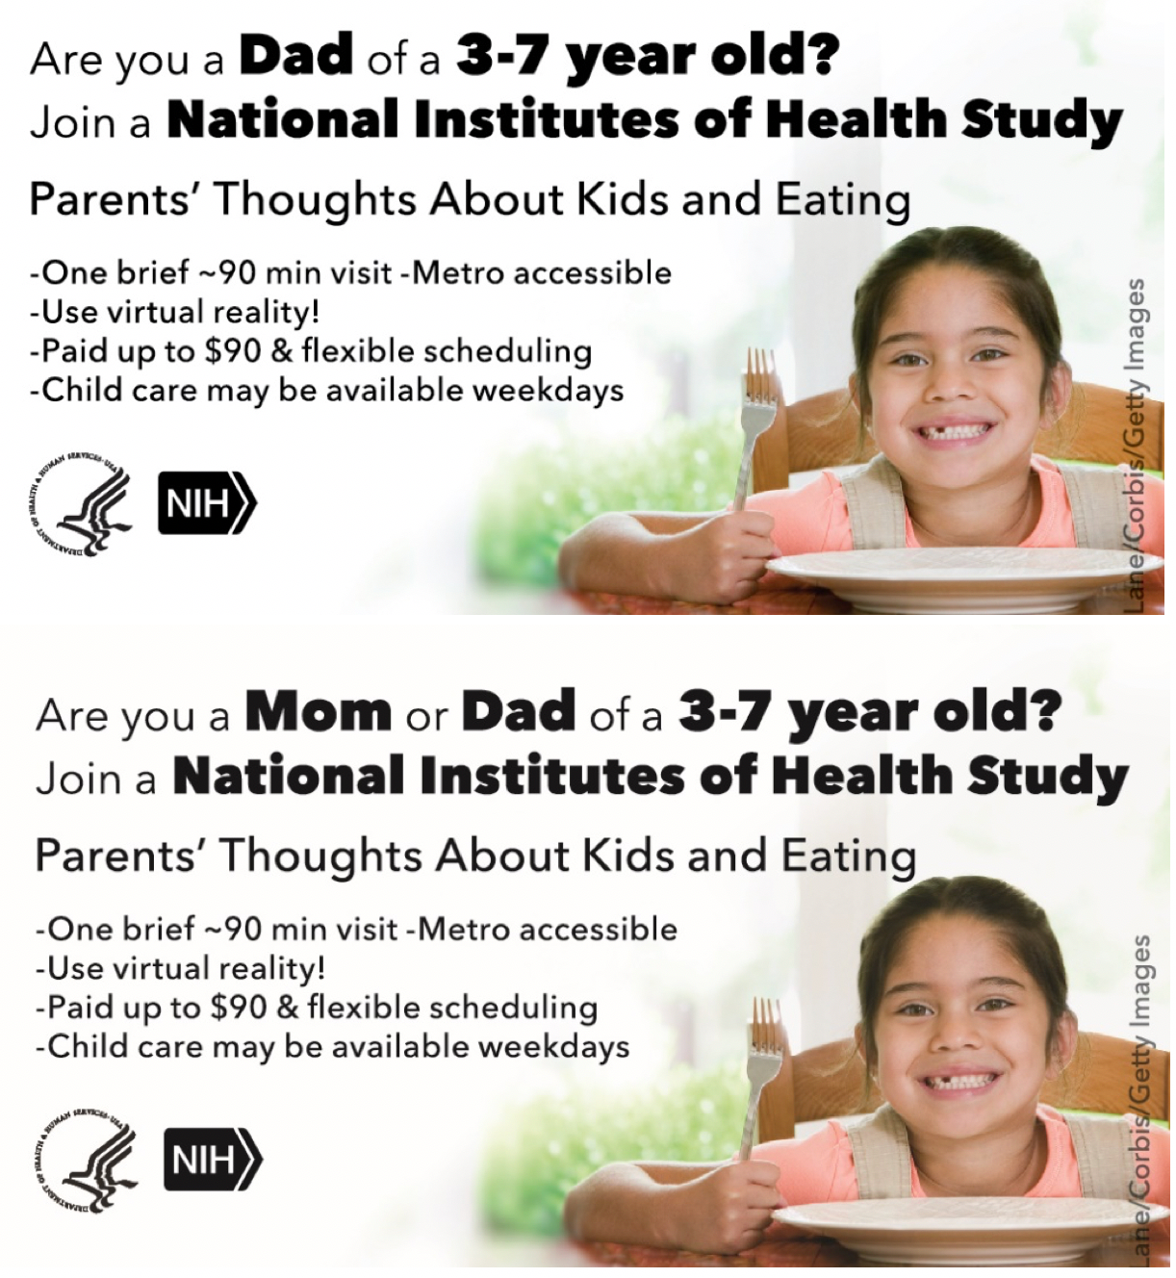

Supplemental Figure 2. Text-based materials exemplar (used for Craigslist, ResearchMatch, and direct mailing)
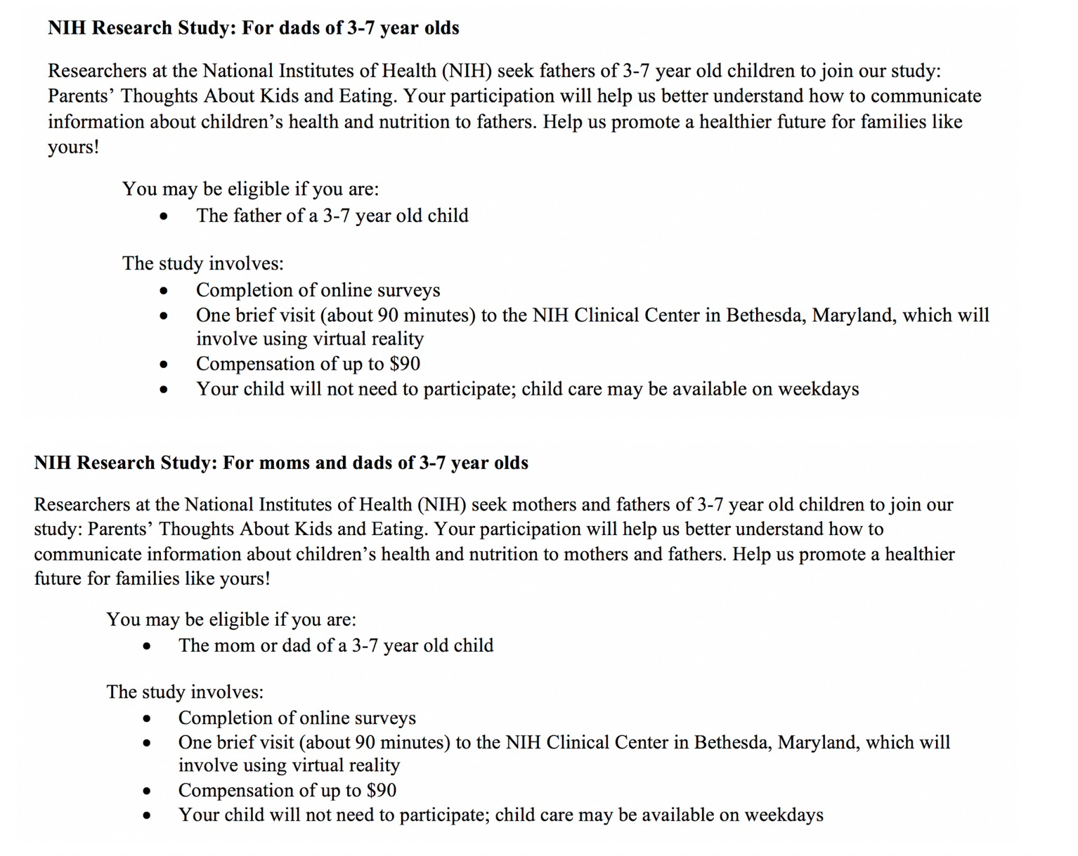

Supplemental Table 1. All Google Ads.

