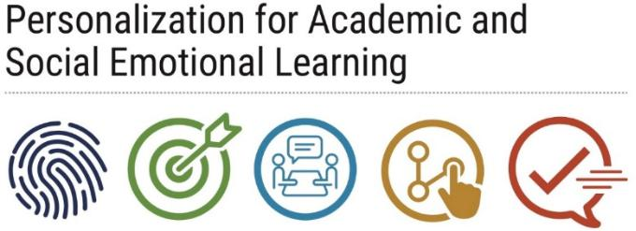
Best Practices for
Collecting & Using Data
Schools are engaging in effective Intentional Use of Data when they are using data as part of a larger organizational system to inform academic, social emotional and behavioral activities.
Best Practices for Using Academic Data
- Successful administrators and teachers draw from multiple sources of data: D & F lists, Interim reports, attendance, Pinnacle, Socrative App, Naviance, etc.
- Teachers at Blanche Ely High School use Crosstalks to discuss specific students who have been identified by their D & F reports. Teachers then develop strategies that may help students to become successful.
- At Coconut Creek High School, administrators and teachers identify all students at or below a 2.0 GPA. The 9th grade administrator and 9th grade teachers then meet weekly to discuss specific students, share strategies, and track student progress.
- Teachers at multiple PASL schools conduct data chats with students discussing their quarterly grades and students’ long and short term goals. Teachers and students at PASL schools have reported that these conversations are helpful. Students have said that these conversations showed that teachers cared.
Best Practices for Using Social-Emotional Data
- Online tools such as Socrative App and Naviance may provide insight into student goals that adults in schools can use to make connections with students and provide support in terms of student academic performance and behavior.
- Several PASL schools use FileMaker Pro to share information among teachers around student goals and interests, reasons for tardiness and absences, and general information deemed relevant to student support.
- Hallandale High School has developed a shared excel file to access, track and monitor student progress. Administrators and teachers can access a student’s grades, behavior infractions, interests, and attendance through this document.
- Piper High School used student data to identify at-risk 9th graders and placed them in their “PASL academy.” These students have a school-within-a school and share classes. Teachers provide consistent one-on-one support to these students.
- At Pompano Beach High School, the guidance counselor collects student data gathered by teachers during rapid check-ins, and advises teachers on how to proceed with students who are struggling. These exchanges occur monthly.

