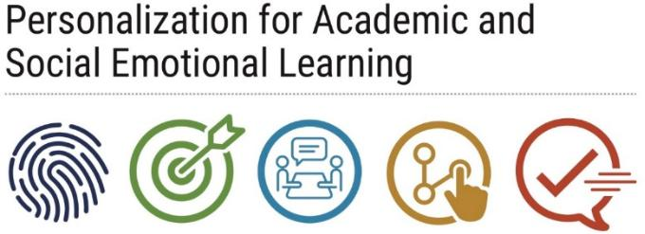
Best Practices for
Implementing &
Documenting RCIs

Best Practices for Implementing Rapid Check-Ins
- Several schools use “Power of Period 1”, “Power of Period 2”, and/or Personalization classes to match a teacher with a group of students over an entire school year. Each teacher makes the effort to conduct a Rapid Check-In with each student in this particular class.
- Teachers at Cooper City High School meet with their students weekly to devise and re-vise short term goals focused on students’ immediate needs (such as passing an upcoming exam, addressing a personal problem, preparing to a sporting event, etc.)
- At Pompano Beach High School, PASL students are assigned to Peer Mentors (e.g. upperclassman) who meet with them weekly to assist the PASL students academically and/or to listen and provide advice.
- Flanagan High School employs a program called Kefford’s Kids, in which D & F students (in groups of less than 10) meet with Guidance and Administrators for additional support.
- Teachers at Monarch High School make a concerted effort to greet their students individually at the door each day; ask students to be “helpers” during lessons and classroom activities; focus on creating dialogue with students throughout the period; and encourage students to share about themselves. These mini-conversations are ongoing and regular, while more formal RCIs occur every three weeks or as needed.
Best Practices for Documenting Rapid Check-Ins
- A number of schools developed accountability mechanisms for keeping track of teachers’ RCIs with students. These included teachers’ comments on FileMaker Pro, an excel spreadsheet, and/or paper copies shared with administrators, as well as other PASL educators and staff.
  - When teachers met in their Educator Team (e.g. 9th grade meetings, Crosstalks, PASL Tuesdays, etc.), they would draw on these notes, comments and experiences.
- At Pompano Beach High School, the guidance counselor collects student data gathered by teachers during rapid check-ins, and advises teachers on how to proceed with students who are struggling. These exchanges occur monthly.

