5-Why’s Activity & Template

5-Why Analysis
The 5-Whys is a simple brainstorming tool that can help teachers and their students identify the root cause(s) of a problem. Once a general problem has been recognized either by the student or the Educator Team, ask “why” questions to drill down to the root causes. Asking the 5-Whys allows you to move beyond obvious answers and reflect on less obvious explanations or causes.

Step-by-step instructions
Example:
Problem: Student comes to school late several times a week.
- Why? Because I have a hard time getting up in the morning.
- Why? Because I go to bed late.
- Why? Because I work the late shift at work.
- Why? Because this is when I get scheduled to work.
- Why? Because this is what is available.

At this point the root cause should emerge and the team can work on what change may be needed.

- State the problem you have identified as a strategic problem to work on.

- Start asking “why” related to the problem. Like an inquisitive toddler, keep asking why in response to each suggested cause.

- Ask as many whys as you need in order to get insight at a level that can be addressed (asking five times is typical). You will know you have reached your final “why‟ because it does not make logical sense to ask why again.

The 5-Whys is a strategy that is often used after an issue has been identified. Guard against using the 5-Whys questions on their own to avoid a narrow focus or bias.

It is said that only by asking "Why?" five times successively, can you delve into a problem deeply enough to understand the ultimate root cause. By the time you get to the 4th or 5th why, you will likely be looking squarely at management practices (more than five whys may be required for complex problems).

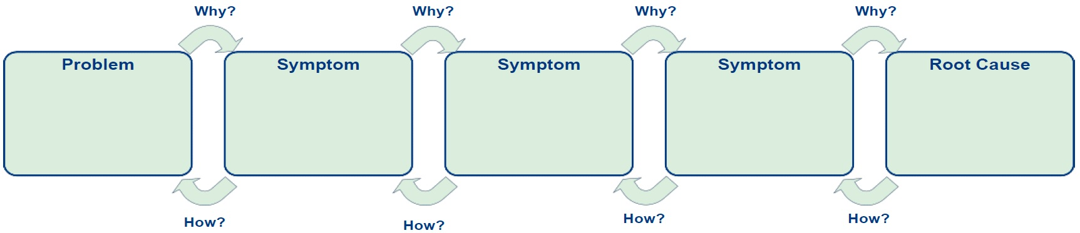
5-Why Analysis Template
Adapted from Mountain Heritage High School, Wikispace, Retrieved 9/9/13: http://mhhspd.wikispaces.com/file/detail/5+Whys+Instructions+and+Template.docx
Asking Powerful Questions

5 Whys Worksheet

Define the Problem:
You don’t want to list 5 different reasons; you want to go deep on 1 reason.

Why is it happening?
Action/Goal:
Why is that?
Why is that?
Why is that?
Why is that?
3.

5.
4.
2.
Caution:
- If your last answer is something you can’t control, go back up to the previous answer on 1 reason

