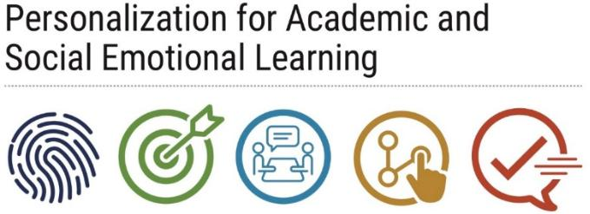
Exploratory Rapid

Check-Ins

Overview
- Exploratory Rapid Check Ins (RCIs) provide an opportunity for teachers to delve deeper when they see that a student might need some extra support, either from the teacher or from support services at the school.
- While most RCIs are routine, the teacher can also have exploratory conversations when there are concerns raised by a student’s grades, attendance, or general behavior.
- Here, teachers use the RCI to delve into the root cause of behavior that raises concerns about the students’ academic status, social emotional state, and behavior.
- Teachers may ask why a student has seemed tired or disconnected. They might also probe why a student has had three days of absences or why they have been chronically late.
- These conversations serve to help solve a problem or they may open up a pathway to other support services offered by the school through the counselor, assistant principal, or school social worker.

Purpose
- Teachers conduct exploratory RCIs when they determine that the student may need extra support.

Implementation
- Teachers conduct exploratory RCIs when it is determined necessary. Sometimes this can follow from a routine RCI if the teacher sees that a student may need a one-on-one conversation.
- Signals that an exploratory RCI is needed include multiple absences, poor grades or a grade decline, recurrent tardiness, fatigue in class, and change in mood and attitude.
- It is important that exploratory RCIs occur when other students are not able to hear the conversation so the student feels comfortable sharing what is accounting for their academic and social behavior.
- If a serious issue is identified during an exploratory RCI, the teacher should reach out to support services at the school to assist the student. This includes the administrator for the grade and the appropriate guidance counselor.
- If a teacher does not feel comfortable having this conversation with the student, that is okay, but they should send them to the appropriate adult.
- Like routine RCIs, exploratory RCIs should be documented.

Details
- One strategy for conducting effective exploratory RCIs is the 5 Why’s Approach.
- The 5-Whys is a simple brainstorming tool that can help teachers and their students identify the root cause(s) of a problem.
- Once a general problem has been recognized either by the student or the Educator Team, ask “why” questions to drill down to the root causes.
- Asking the 5-Whys allows you to move beyond obvious answers and reflect on less obvious explanations or causes.
- The 5 Why’s Approach is not exclusive to exploratory RCIs but they are a useful tool in helping the student figure out what the root causes of their issue is.
- For example, if a student is recurrently tardy, the 5 Why’s helps the student establish the root causes of the tardiness.

Connection to other components
- Exploratory RCIs build on Goal Setting to help the student understand why it is important to address issues that might be impeding their success.
- It can be scaffolded with data to help the teacher and the educator team provide services to the student.
- As students feel that adults are helping them succeed in school, this helps to build a Culture of Personalization.

Materials
- 5 Why Activity and Template

