HOD 2 290: R ESEA R CH EX PER I EN CE
HOD 2 990: H O D H O N O R S SEM I N A R

Spring 2012, Wednesday 2:10 to 4:00, Room: Payne109
Prerequisite: HOD 1700 or equivalent research methods intro
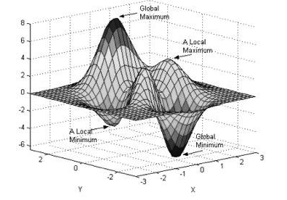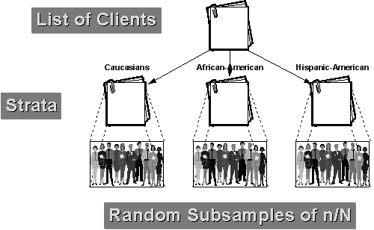
Instructor: HOD Prof. Douglas D. Perkins Unofficial TA: Nikolay Mihaylov
Office: Mayborn 107 Phone: 322-7213 Office: Mayborn 301
Email: d.perkins@vanderbilt.edu Email: nikolay.mihaylov@vanderbilt.edu
Office hours: by appt. Office hours: by appt.

COURSE DESCRIPTION
This course is designed to provide students with hands-on experience in conducting social science research. The course is especially tailored for students interested in going on to graduate school, but the logic and skills emphasized are important to all students in the information economy. Students from Honors and HOD Research Experience will meet together for this class to develop common analytic skills and knowledge and share research experiences. There will also be small group or individual meetings between student(s) and instructor.

The course will provide training in the range of methods expected of researchers: literature reviews, research questions and design, sampling, data collection and statistical or qualitative analysis. Students will work with faculty and graduate students in the HOD or LPO Departments (or possibly elsewhere) on ongoing research projects. Students will work on different aspects of the research they are involved with, but will be required to develop a research question and write a research report comprising a review of relevant empirical literature, methods and results, and to make a presentation about their study.

COURSE OBJECTIVES: At the completion of this course students are expected to demonstrate:
1. A greater understanding of research methods.
2. A tangible research idea or proposal for study.
3. Valuable participation in an applied research project with exposure to a range of dimensions in the research process including literature reviews, research design, data collection and statistical analysis.
4. A write-up and presentation of a complete study including research question, literature, methods and analysis.

READINGS: Most of the readings will be your responsibility to identify re your chosen project (along with any your project supervisor provides or recommends). Plus, we will use just a few joint readings from journal articles to sharpen critical thinking and research skills.

COURSE GRADING
1. Attendance and participation in class are expected. Since the primary focus of this course is applied experience in research, this course will not meet every week of the semester. You will be required to meet with the instructor on some weeks, even if there is no formal class. It is especially important, then, to read the assigned materials and engage in the class discussions when class does meet. Class participation represents 10% of your grade.
2. Written specific and constructive feedback on draft report sections to all members of your feedback/support group is 10% of your grade.
3.Full participation with your faculty mentor and the research team of the project you will be working with is expected. Your participation in this work– to be spelled out in a learning contract with this mentor – will represent 10% of your grade.
4. Two research products will be graded for this course. We will discuss product formats (written reports, presentations, etc.) in class, but a write up of your study will be 60% of your grade and an oral presentation of your study will be 10% of your grade.

COURSE CALENDAR, READINGS, ACTIVITIES
* Shaded dates are for full class meetings.
Jan. 11 Introduction; syllabus, learning contract; possible research projects.
Jan. 18 Report on faculty interviewed about project(s); Methods review; read Botvin, Baker, Dusenbury, Tortu & Bovin. (1990). Preventing adolescent drug abuse through a multimodal cognitive-behavioral approach: Results of a 3-year sudy. Journal of Consulting and Clinical Psychology, 58 (4), 437-446.
Jan. 25 Lit search due; Report on faculty and project final decisions & completed learning contract (due today); Instructor will assign feedback/support groups based on similar projects or topics; Methods review, IRB; Read Van Biema, D. (Nov. 11, 1996). Just say life skills: A new school antidrug program outstrips DARE. Time; + Botvin, Baker, Dusenbury & Bovin. (1995). Long-term follow-up results of a randomized drug abuse prevention trial in a white middle-class population. Journal of the American Medical Association, 273 (14), 1106-1112.
Feb. 1 Article review/critique due; Report on initial project plan and activity; Read Cohn, J. (2001). Drug education: The triumph of bad science. Rolling Stone (May 24), 41-42, 96. + Gorman, D.M. (1998). The irrelevance of evidence in the development of school-based drug prevention policy, 1986-1996. Evaluation Review, 22 (1), 118-146.
Feb. 8 Lit review matrix + draft outline due; Read & discuss Bem, D. J. (1995). Writing a review article for Psychological Bulletin. Psychological Bulletin, 118, 172-177. + Bem, D.J. (2003). Writing the empirical journal article. In J.M. Darley, M.P. Zanna, & H.L. Roediger (Eds.), The complete academic: A practical guide for the beginning social scientist, 2nd Ed. APA.
Feb. 15 Individual Meetings
Feb. 22 Individual Meetings
Feb 29 Individual Meetings
Mar. 14 Individual meetings; post draft Introduction, Literature Review, Hypotheses (or Research Questions), Methods, References sections of final report to OAK Discussion; review and comment on all drafts in your feedback group by 3/21
Mar. 21 Discuss above draft sections of report & feedback
Mar. 28 Individual meetings
Apr. 4 Individual meetings
Apr. 11 Individual meetings; post draft Results and Discussion sections of report to OAK; review and comment on all drafts in your feedback group by 4/16
Apr. 18 Project presentations
Apr. 25 Final Report due, including Title, Abstract, & revised sections above

