Geospatial Analysis of the Global Growth of Community Psychology: Geographic Proximity and Socioeconomic and Political Indicators

M. Reha Ozgurer and Douglas D. Perkins
Vanderbilt University
(In press). Journal of Community Psychology

Acknowledgment
We thank Dominique Lyew, Nikolay Mihaylov, and Camila Rivas-Garrido for their help researching and compiling the quantitative data used here. This study was supported in part by the Russell G. Hamilton Fund for Human & Organizational Development at Vanderbilt University.

Abstract
Data on 105 countries from the Global Development of Applied Community Studies project and a geographic information system (ArcGIS) were used to map and identify spatial patterns in the international growth of community psychology, as measured by professional associations and conferences, graduate and undergraduate programs and courses, and publications. Our primary aim was to analyze the field’s global development, emphasizing professional training and research products, in the context of geographic proximity and theories of knowledge transfer and knowledge spillover. The results of Hot Spot Analysis and Cluster and Outlier Analysis spatially confirmed our hypothesis, revealing statistically significant hot spots of the strength of community psychology in the countries sharing borders. Hierarchical regression analysis found that the strength of community psychology in neighboring countries significantly predicted the development of community psychology beyond the influence of population size, Human Development Index, freedom score, and a history of grassroots activism. Implications for theory, research, and international professional and student exchanges are discussed.

Keywords: GIS, community psychology, geospatial analysis, knowledge transfer and spillover, geographic proximity

Geospatial Analysis of the Global Growth of Community Psychology
Community psychology examines how individual lives and well-being are interconnected with institutions and other social systems and the functioning of communities, especially for socially and economically disadvantaged members (Levine, Perkins, & Perkins, 2015). Given that emphasis on disadvantage—as well as our increasingly globalized world and the fact that community psychology has spread to over 40 countries (Perkins, 2009)-- it is especially important for psychologists and students in low and moderate-income countries (LMICs) to be aware of what community psychology offers to help them address oppressive conditions and develop strengths in those countries. Evidence shows, however, that community psychology has failed to take root in most LMICs, especially in Africa, most of Asia, and the smallest and poorest countries of Latin America and the Caribbean (Hanitio & Perkins, 2017), which may be due in part to unintended consequences of foreign aid to those countries (Lyew et al. in press). Therefore, identifying and examining both the global dispersion and “deserts” of community psychology should be a priority.
This study is an attempt to understand the geospatial patterns of the development of community psychology across the world. More specifically, it estimates the strength of community psychology as a professional and research discipline in each country and examines how the development and geographic spread of the field relates to the theories of knowledge transfer and knowledge spillover. In particular, we aim to reveal whether the development of community psychology in one country significantly predicts the development of the same field in neighboring countries, especially in the socioeconomically developing ones that could benefit the most.
Global Growth of Community Psychology
Community psychology has been defined similarly across many countries. In Latin America, as in the U.S., it refers to psychosocial theory, research, and intervention for the development of community capacities and resources to address systemic problems (Montero, 1998). Community psychology aims to solve societal social, psychological, and health and wellness problems at the local level by addressing inequities and social injustice through real and practical improvements in, not only individual wellness, but the living conditions of communities (García-Ramírez, Balcázar, & Freitas, 2014). The development of community psychology in a country is vital because it can help disadvantaged communities and the individuals in them to not only gain more control over their own lives, but to also contribute to and improve the functioning of the entire society (Reich, Riemer, Prilleltensky, & Montero, 2007).
Therefore, especially in the context of individual, organizational, community, and societal empowerment, some scholars have focused on how training in community psychology can be more effective in analyzing and addressing change at all those levels. For example, in one of the relatively few LMICs with strong community psychology, Pillay (2006) investigated how educational psychology students at a South African university experienced their training in community psychology and proposed developing more cohesive, holistic, context-relevant and practice-oriented training in community psychology, including exposure of students to diverse community groups, focusing on preventive methods instead of curative ones, and including more racially and ethnically diverse students in community psychology programs.
Despite the noble purposes of the field of community psychology, such as providing transformative solutions that address the systemic root causes of community problems, the development of this field has been limited to certain countries and geographies in the world. Ironically, the countries that would most benefit from community psychology are least likely to have it available (Perkins, 2018). This contradicts “the spirit of community psychology” (Kelly, 2002). Unlike more individualistic branches of psychology, community psychology does not ignore the reality that individual behaviors, cognitions and wellness are shaped, not only by biology and the microsystem of one’s immediate relationships, but also by meso-, exo-, and macro-systemic and structural factors. That is why community psychology should not be limited to just certain countries, especially not just those with the most resources to potentially deal with problems at the most commensurate and effective level of society. We must therefore better understand all the promoting and inhibiting factors, both current and historical, as well as any geographic patterns, in the development of community psychology as both a professional and scientific field all around the world.
The origins of community psychology can be found in just a few places, primarily in the United States, and within social psychology in Latin America and Western Europe in the 1950s through the 1970s (Reich et al. 2007). But then it gradually spread to at least minimal presence (i.e., at least one community psychology publication, conference, course or training program) in currently over 60 countries on six continents (Hanitio & Perkins, 2017; Perkins, 2009). There are both consistencies but also varying conditions, cultural responses, political realities, social science theories, methods and applications that have influenced what community psychology looks like around the globe. Importantly, we are not proposing a monolithic “global community psychology.” In contrast, Marsella (1998) defines “global-community psychology” (with critical emphasis on the hyphen in that name) as “a superordinate or meta-psychology concerned with, understanding, assessing, and addressing the individual and collective psychological consequences of global events and forces by encouraging and using multicultural, multidisciplinary, multisectoral, and multinational knowledge, methods, and interventions” (p. 1282). Although this definition is valuable in emphasizing the influences of global events and forces, we believe that creating a global community psychology (no hyphen) should involve finding not only global universalities such as the historical and persistent influences of colonization and macroeconomic hegemony, but equally important, the unique factors associated with the development of community psychology in each country and mapping the current strength of the field to see the geospatial patterns of its development.
There are few studies examining the universal and unique-to-country factors together. For instance, Hanitio and Perkins (2017) examined whether (controlling for population size) socioeconomic and political indicators including level of civil liberties, Human Development Index (HDI), and history of grassroots activism significantly predict a country’s current strength of community psychology and community development. Using the database of the Global Development of Applied Community Studies Project which contained data about socioeconomic and political predictors and current strength of the development of community psychology and community development in 97 countries, the researchers found that each predictor was significantly and positively associated with the current strength of community psychology. Moreover, this study examined the unique-to-country factors by conducting brief qualitative comparative case studies of Chile and Ghana and found that the development of community psychology in those country may depend on a complex mixture of factors such as the influences of political and intellectual colonialism by other nations, whether or not there was an integration of top-down government policies and bottom-up action, and advancements in relevant social science disciplines.
The development of community psychology is especially important in socioeconomically or democratically developing countries because they have significantly more, and more seriously, disadvantaged communities than in the Global North. The relationship between both low HDI and inequality around the world, on the one hand, and a host of negative health and social outcomes, on the other, is well established (Wilkinson, & Pickett, 2009). Another geographic study conducted by Kummu and Varis (2011) investigated the evolution and status of various indicators including population size, social and economic development, and natural resources from a scientific perspective by examining those indicators across the north-south axis, and particularly their progress and development over the past half-century. The researchers found that most of the world’s poverty, environment, and development related problems were located in the countries close to the equator and these problems were mostly decreasing as one gets away from it.
These examples reveal the urgent need for the global growth of applied social sciences, such as community psychology, that can address a broad range of problems at all ecological levels from policy through community and organizational interventions to individual behaviors and outcomes. For this purpose, we should first map the current strength of community psychology across the globe so that we can see, and more precisely identify, which parts of the world have great needs but little or no evidence of community psychology and what might be some geographic factors triggering development of the field and barriers to such development.
Geographic Information Systems
Geographic information systems (GIS) is a computer application that enables researchers to create, visualize, and analyze geographic information (Goodchild, 2000). In the social sciences, GIS is important because it is a strong mediator of sociopolitical power, spatial knowledge, and intellectual practice (Elwood, 2006). It has been compellingly advocated as a useful, ecological, but generally overlooked methodology for community psychology (Huber, Van Egeren, Pierce, & Foster-Fishman, 2009; Luke, 2005; Perkins, Larsen, & Brown, 2009). The importance of GIS techniques in empowering communities was shown in a striking action research study conducted by Wood (2004). With the purpose of examining whether different community groups could themselves use computer software and digital mapping techniques to efficiently focus on local issues and knowledge over countryside concerns, this study collected qualitative data through semi-structured interviews and focus groups from members of seven community groups, as well as map project managers, local GIS officers, and geographic information users/facilitators. The researcher became an active participant in both the study and the organizations in an effort to detect problems groups encountered regarding the use of maps, spatial information, and GIS in facilitating community engagement. While the results showed that GIS mapping can help empower community groups and can become a useful community based participatory GIS tool, ongoing help from a facilitator or volunteer with GIS skills was required, suggesting that applied geography is another important field to track globally.
As with the present study, GIS can be usefully applied to analyzing the geographic patterns of where vital professional human resources are scarce, lost or gained, such as a study that tracked Sub-Saharan African physician migration and recruitment to the United States, which is critical for understanding the worsening global problem of medical brain drain from the poorest to the wealthiest countries (Tankwanchi, Vermund, & Perkins, 2015). They found that physicians migrating from Africa to the U.S. located predominantly in metropolitan areas east of the Mississippi River; and that within the U.S. the areas most in need of trained medical personnel attracted the lowest numbers of migrant physicians. Not surprisingly, local racial diversity seems to serve as a magnet for migrant doctors with many clustered in urban areas with a high black population and where earlier immigrants had settled. To our knowledge, the only effort to map the current strength of the field of community psychology across the world (Perkins, 2018) did not use GIS with all of its advantages of accuracy, efficiency, and spatial analysis.

Theoretical Framework
One factor that triggers the development of community psychology in a country may be the influence of adjacent countries. Influence can be in any form (e.g., political, cultural, religious), and there are most likely various individual (e.g., migration for training, employment, or other reasons), micro- (e.g., international research collaborations) and macro-systemic (common language) factors that causes one country to influence its neighboring countries regarding the emergence and development of an academic field. However, given that there has been no prior scientific effort on spatial analysis of the development of community psychology, this study starts with employing the concepts of knowledge transfer and knowledge spillover as theoretical explanations for the influence of geographic proximity on the development of community psychology.
Knowledge refers to "the application and productive use of information... it involves an awareness or understanding gained through experience, familiarity, or learning” (Roberts, 2000, p. 430). Knowledge transfer, generally examined by scholars in the discipline of economy or management, occurs when one entity disseminates knowledge to another (Welch, & Welch, 2008). We assert that geographic proximity can have a positive or negative impact on the development of community psychology in bordering countries by facilitating knowledge transfer. Although geographic proximity is not a necessary or sufficient condition for knowledge transfer, it indirectly assists the progress of interactive learning and promotes the generation of new knowledge required for innovation (Boschma, 2005) by creating a space for face-to-face communication through which a knowledge recipient gain better understanding of new ideas (Sjöholm, 1996). When the new piece of knowledge is more sophisticated, as in the case of emergence of an academic field in a country, face-to-face communication and personal contact becomes more important, especially if the knowledge recipient is capable of interpreting it successfully (Rogers, & Shoemaker, 1971).
Some studies demonstrated the relationship between knowledge transfer and geographic proximity. For instance, examining the relation between academic research in universities and patent applications in 29 states of the U.S., Jaffe (1989) found that geographic proximity influenced the amount of knowledge transfer, meaning that companies were more likely to benefit from research and development in universities when those universities were in their home states. In an international context, the qualitative study of Korbi and Chouki (2017) found that geographic proximity between Tunisian small-and-medium enterprises (SMEs) and European multinational corporations (MNCs) was a significant factor in the transfer of explicit as well as tacit knowledge. These findings confirm that geographic proximity establishes effective communication between local, national, or international partners and ensures a better transfer of knowledge (Gomes-Casseres, Hagedoorn, & Jaffe, 2006). Therefore, we posit that geographic proximity can trigger the emergence and development of community psychology which is a product of knowledge transfer through facilitating intensive communication and face-to-face idea sharing between community psychologists in countries that share their borders with each other.
Secondly, the concept of knowledge spillover in economics and business literature provides us with another theoretical framework that can be applied to our study as well. Knowledge spillover refers to “the exchange of ideas among individuals” (Carlino, 2001, p. 17) and is an essential factor in economic growth, technological advancement, and the nature and quality of cities (Henderson, 2007). Although knowledge spillover resembles knowledge transfer, there is an important difference between them, which is that knowledge transfer is an intentional process, whereas knowledge spillover occurs outside the intended boundary (Ko, & Liu, 2015). Knowledge spillover is influential in the development of local businesses in a country, especially in the emerging economies. For example, Filatotchev, Liu, Lu, and Wright (2011) found that the returnee entrepreneurs (i.e. scientists and engineers who returned to their native countries and started up a new venture there, after gaining business and/or educational experience in socioeconomically developed countries) significantly increased innovation in other local firms and businesses in China. Simmie (2003) proposed two main reasons for the effect of knowledge spillover in the development of local businesses. First, the proximity of the actors facilitates the exchange of new knowledge in the social networks. Second, high labor mobility between qualified workers, which partly results from the proximity of the actors, makes the knowledge transfer easier in local areas. The effect of knowledge spillover may be true for neighboring countries as well. Supporting this point, one study showed that there was a significant similarity between neighboring countries in terms of the products they exported (Bahar, Hausmann, & Hidalgo, 2012). More specifically, the probability that a country’s export basket included a product was found to be 65% higher, when that product was a common export item in the neighboring countries. The researchers concluded that this similarity was “suggestive of localized intra-industry technological spillovers” (Bahar, Hausmann, & Hidalgo, 2012, p. 40). Likewise, our assumption is that the development of community psychology in one country can trigger the development of the same field in neighboring countries partly because of knowledge spillover. The proximity of these countries as well as the existence of community psychologists in one country, be it returnee or not, can facilitate the knowledge spillover process.
Present Study
Other than some attention to the breadth of countries and forms of community psychology that have spread globally (Reich et al. 2007), the literature in community psychology has largely overlooked the key questions of precisely how and where the field has been distributed across the globe and what factors might influence this distribution. In other words, the field of community psychology has been so absorbed in studying its subject matters that it overlooked its own development and strength in the world. This study aims to fill out this gap by spatially and statistically showing the development of community psychology and which factors might be related to its development.
We suggest that one important factor regarding the development of community psychology in a country is the influence of neighboring countries. Therefore, we hypothesize that there will be a statistically significant hot spots of community psychology on the continents or regions where community psychology has its roots, whereas there will be statistically significant cold spots of community psychology on the continents or regions where community psychology has shown no or limited progress. Furthermore, we hypothesize that geographic proximity will significantly predict the variance in the strength of community psychology in a country above and beyond the influences of other socioeconomic predictors-- population size, social and economic development, grassroots activism, and civil liberties and political rights. This analysis builds on Hanitio and Perkins (2017) in three ways: first by replicating their results for a larger number of countries (105 vs. 91). Second, we add the additional predictor of political rights, which-- along with the civil liberties ratings Hanitio and Perkins used-- form a broader Freedom Score. Third and most important, we add the additional new predictor of geographic proximity to other countries and how strong community psychology is in those counties; and then we systematically map and analyze the geospatial distribution of community psychology throughout the world.

Method
Sample and Design
The data for this study was collected from the database of Global Development of Applied Community Studies (GDACS) project. This project examines and compares the development of 12 community-related academic disciplines focusing on solving social problems at the community level. For this purpose, GDACS contains current numerical strength of the following academic disciplines in 105 countries: community psychology, community sociology, community development, community social work, interdisciplinary community studies, applied/development anthropology, development economics, public health, urban/regional planning and geography, public administration/policy studies, community/popular education, and liberation theology and religious studies. This study employed only the data on the current strength of community psychology across the countries.
105 countries in the dataset of GDACS were non-randomly selected based on various criteria (Hanitio, & Perkins, 2017). First, 30 countries were included because they were known to have established community psychology programs, journals or organizations. Then, the countries with at least ten million population were selected with some exceptions. For instance, North Korea having a population of approximately 25 million was not included because there was not enough data obtained on that country. On the other hand, Jamaica, Sweden, and Paraguay each of which has population below 10 million were added to the dataset because community psychology and other community-related academic fields were developed in those countries. Lastly, Palestine and Israel were separated in the dataset because of their differences in terms of sociopolitical and economic indicators.

Measures and Instruments (see Table 1for descriptive statistics on each variable)
Geographic Information Systems
This study employed ArcGIS 10.6.1, a geographic information systems (GIS) software developed by a worldwide provider of GIS software. This software enables the researcher to work with maps and spatial information. Data collection and analysis were done on personal computers of the authors and data were stored in computer files.
[INSERT TABLE 1 ABOUT HERE]
Geographic Proximity
In the context of this study, geographic proximity is a term that indicates the spatial relationship between a country and its neighboring countries. We created a proximity score for each country to operationalize geographic proximity. The formula used to estimate the score included the length of the border between a country and each of its neighbors and the current strength of community psychology in each neighbor. The unit of length was kilometer. First, we calculated the proportion of the border length between the country and one of its neighbors to the total border length of that country. Second, we multiplied the proportion that we calculated for each neighbor with the current strength of community psychology of that neighbor. Last, we summed up each multiplied score to create a single proximity score. One important point is that we did not include the countries that are not in the dataset of GDACS when using the formula. Otherwise, it could create a bias to include their border length in the formula while excluding their current strength of community psychology, which we do not know. To give an example, Angola’s neighbors are Democratic Republic of Congo (DRC), Zambia, and Namibia. The border length between Angola and each of its neighbors is 2646, 1065, and 1427 kilometers, respectively. Not taking into account Namibia because it is not in the database of GDACS, the proportion of border length between Angola and DRC is 0.71, while it is 0.29 for Angola and Zambia. Also, the current strength of community psychology of DRC is 0, whereas it is 1 for Zambia. Therefore, the proximity score of Angola is 0.29 (i.e., 0.71 x 0 + 0.29 x 1). This score quantified the total influence of neighboring countries on the development of community psychology in the country which they border.
Before starting the calculation, we established a decision rule for island countries, since they do not have any land borders. First, we used Google Maps to find the smallest distance between an island country and its closest neighbor, which could be another island or non-island country. Then, we found other countries from which the island country was twice or less as distant as the closest neighbor. Moreover, we reversed the distances when calculating the proportion of border length because the closest neighbor, which had a lower distance score, was supposed to have more influence.
Current Strength of Community Psychology
Our criterion variable was current strength of community psychology which is a measure showing the development of the field in a country. We have measured it on an 11-point scale in which 0 means “no evidence of the field” and 10 means “highly developed field”. The measurement takes into account the presence of some evidence on community psychology in each country. The evidence and coding criteria are as the following: (a) 1 point for at least one formal professional organization or conference, (b) 1 point for at least one undergraduate course, (c) 1 point for at least one undergraduate program, (d) 1 point for at least one graduate course, (e) 2 points for one graduate program or 3 points for multiple graduate programs, and (f) 1 point for one to five academic publications, 2 points for more than five academic publications, or 3 points for at least one scholarly journal.
Social and Economic Development
Our study used the United Nations Development Programme’s Human Development Index (HDI), based on the data in 2017, as a means to measure social and economic development in a country. The HDI summarizes the achievements of countries in the world in three key aspects of human development: knowledge accessibility, a satisfactory standard of living, and a long and healthy life (UNDP, 2019). It is based on the geometric mean of normalized indices for each of the aspects and the idea that measuring the development of a country must include people and their competencies as well.
Civil Liberties and Political Rights
We employed Freedom House’s (2015a) annual Freedom in the World report to determine the general freedom rating of each country. Freedom in the World report formed survey-based numerical scores to show the state of political rights and civil liberties in 195 countries and 15 related and disputed territories in 2014 (Hanitio, & Perkins, 2017). The civil liberties measure included 15 questions under four major subcategories: Freedom of Expression and Belief, Associational and Organizational Rights, Rule of Law, and Personal Autonomy and Individual Rights (Freedom House, 2015b). The political rights measure included 10 questions under three major subcategories: Electoral Process, Political Pluralism and Participation, and Functioning of Government (Freedom House, 2015b). Each measure assigned ratings on a 7-point scale fixed at 1 with “the greatest degree of freedom ” and at 7 with “the smallest degree of freedom”. Our study employed the general freedom rating calculated by taking the average of civil liberties and political rights ratings for each country. For purposes of interpretation, we reversed the scale in a way that 1 represented the smallest degree of freedom and 7 the greatest degree of freedom.
Grassroots Activism
In this study, the existence and strength of grassroots activism in 105 countries was based on Swarthmore College’s Global Nonviolent Action Database (2015; SCGNAD). The database has more than 1000 cases and summaries of successful nonviolent activism such as peaceful strike, protest, or sit-in, including campaigns even dating back to 2000 years ago. However, because there were extreme scores for the United States as well as some other countries regarding nonviolent action, we needed to adjust for positive skewness. Therefore, our study used the same measure but with a base-10 logarithmic transformation (Hanitio, & Perkins, 2017).
Population Size
We used the data of CIA World Factbook (2015) to determine the national population of each country with the exception of Palestine. Its population estimate was based on the World Population Review (2015).
Data Analysis
The analysis of this study consisted of two parts. In the first part, we conducted hierarchical multiple regression to test our hypothesis which posited that geographic proximity was a significant and unique predictor of strength of community psychology in 105 countries above and beyond the influences of population size, HDI, freedom score, and grassroots activism. In the second part, we employed three interrelated spatial analyses in order to reveal the spatial relationship among the countries examined in GDACS in terms of strength of community psychology, geographic proximity, HDI, grassroots activism, and freedom score. These analyses were (1) spatial autocorrelation analysis using Moran’s I statistic, (2) cluster and outlier analysis using the Anselin Local Moran's I statistic, and (3) optimized hot spot analysis using Getis-Ord Gi* statistic.
Spatial autocorrelation in GIS is used to understand the degree to which one point, line or polygon is similar to other neighboring points, lines, or polygons based on feature values and feature locations at the same time (Ding, & Fotheringham, 1992). Calculating the Moran’s I Index value, the z-score, and the p value, this analysis reveals whether the spatial pattern is significantly clustered or randomly dispersed. Likewise, cluster and outlier analysis maps the cluster of features having high or low values. One advantage of this tool is that it reveals the spatial outliers as well. Optimized hot spot analysis identifies the hot spots and cold spots of a given set of features by analyzing each feature within the context of nearby features (Grubesic, & Murray, 2001). The major difference between the optimized hot spot analysis and non-optimized one is that the former does automatic calculation of the parameters including distance band based on the characteristics of your data, which provides a safer and more reliable means for analysis.
Results
Supporting our hypothesis, simple bivariate Pearson correlation analysis showed that there was a significant positive correlation between strength of community psychology and geographic proximity (r = .46, n = 105, p < .001) (see Table 2). Also, this study confirmed the results of Hanitio and Perkins’s (2017) research by revealing the significant positive correlation between strength of community psychology and population size (r = .20, n = 105, p < .05), HDI (r = .49, n = 105, p < .001), grassroots activism (r = .51, n = 105, p < .001), and freedom score (r = .50, n = 105, p < .001).
[INSERT TABLE 2 ABOUT HERE]

Moreover, we conducted hierarchical multiple regression analysis to see whether geographic proximity significantly and uniquely predicted strength of community psychology. First, we added the variables, population size, HDI, and freedom score into the model and found that they explained 34.9% of the variance in strength of community psychology (p < .001). Then, we added the variable, grassroots activism into our model, and found that it significantly explained 5.3% additional variance after controlling for population size, HDI, and freedom score, replicating the results of Hanitio and Perkins’s (2017) research (p < .01). Lastly, we added our primary predictor of interest-- geographic proximity—into the model. The results revealed that geographic proximity significantly explained 4% additional variance after controlling for other country-level contextual variables (p < .01), (see Table 3).
[INSERT TABLE 3 ABOUT HERE]
To sum up, our findings revealed the significant positive association between strength of community psychology and geographic proximity. Also, we found that geographic proximity significantly contributed to the variance in strength of community psychology above and beyond the influences of population size, HDI, grassroots activism, and freedom score.
Hot and cold spots distribution of strength of community psychology
Pearson’s correlation coefficient (R) for strength of community psychology showed statistically significant global clustering across the world (Moran’s I = 0.28, Z = 8.05, p < .00001). The global clustering using Moran’s I was supported, when we performed an optimized hot spot analysis using Getis-Ord Gi* statistic. The optimized hot spot analysis revealed two major hot spots of high strength of CP and two cold spots of low strength of CP (Figure 1). The high strength of CP hot spots included: (1) Seven countries in South America, which are Argentina, Brazil, Bolivia, Chile, Paraguay, Peru, and Uruguay; (2) two countries in Oceania, which are Australia and New Zealand. The strength of CP cold spots included: (1) 16 countries in Africa, which are Angola, Cameroon, Chad, Democratic Republic of Congo, Egypt, Ethiopia, Kenya, Malawi, Niger, Nigeria, Rwanda, Somalia, South Sudan, Sudan, Tanzania, and Uganda; (2) 14 countries in Asia, which are Afghanistan, India, Iran, Iraq, Israel, Kazakhstan, Lebanon, Nepal, Pakistan, Russia, Saudi Arabia, Syria, Uzbekistan, and Yemen.
Cluster and outlier analysis using Anselin Local Moran’s I identified four high-low outlier spots, where five countries had significantly higher strength of CP compared to that of their neighbors, and one low-high outlier spot, where one country had significantly lower strength of CP compared to that of its neighbors (Figure 2.). The high-low outlier countries were Egypt, India, Italy, Mozambique, and Zimbabwe, whereas the low-high outlier country was Ecuador.
[INSERT FIGURES 1 AND 2 ABOUT HERE]
Hot and cold spots distribution of Human Development Index
Pearson’s correlation coefficient (R) for Human Development Index (HDI) showed statistically significant global clustering across the world (Moran’s I = 0.64, Z = 14.21, p < .00001). The global clustering using Moran’s I was confirmed, when we performed an optimized hot spot analysis using Getis-Ord Gi* statistic. This analysis revealed one major hot spot of high scores and one cold spot of low scores in HDI (Figure 3). The hot spot of the high scores in the HDI included 20 European countries, which are Bulgaria, Czechia, Denmark, Finland, France, Germany, Greece, Hungary, Ireland, Italy, Netherlands, Norway, Poland, Portugal, Romania, Turkey, Spain, Sweden, Ukraine, and United Kingdom, and one country in Africa, which is Tunisia. On the other hand, the cold spot of the low scores in HDI included 24 African countries, which are Angola, Burkina Faso, Cameroon, Chad, Democratic Republic of Congo, Ethiopia, Ghana, Guinea, Kenya, Madagascar, Malawi, Mali, Mozambique, Niger, Nigeria, Tanzania, Rwanda, Senegal, South Africa, Somalia, Sudan, South Sudan, Uganda, and Zambia, and two countries in Asia, which are Saudi Arabia and Yemen. In Figure 3, the clustering of strength of CP (large dots) in the European HDI hot spot and little or no CP (small dots) in the African HDI cold spot are readily apparent.
[INSERT FIGURE 3 ABOUT HERE]
Hot and cold spots distribution of high and low scores in freedom score
Pearson’s correlation coefficient (R) for freedom score found statistically significant global clustering across the world (Moran’s I = 0.49, Z = 12.14, p < .00001). An optimized hot spot analysis using Getis-Ord Gi* statistic confirmed the global clustering using Moran’s I. Optimized freedom score hot spot analysis revealed one major hot spot of high scores and two cold spots of low scores in freedom score (Figure 4). The hot spot of the high scores included: (1) 19 countries in Europe, which are Bulgaria, Czechia, Denmark, Finland, France, Germany, Greece, Hungary, Ireland, Italy, Netherlands, Norway, Poland, Portugal, Romania, Spain, Sweden, Ukraine, and United Kingdom; (2) two African countries, which are Morocco and Tunisia. On the other hand, The cold spots of low scores included: (1) 19 countries in Africa, which are Angola, Cameroon, Chad, Democratic Republic of Congo, Egypt, Ethiopia, Ghana, Guinea, Kenya, Malawi, Mozambique, Niger, Nigeria, Rwanda, Somalia, South Sudan, Sudan, Tanzania, Uganda, and Zambia; (2) 16 countries in Asia, which are Afghanistan, Bangladesh, India, Iran, Iraq, Israel, Kazakhstan, Lebanon, Nepal, Pakistan, Russia, Saudi Arabia, Syria, Thailand, Uzbekistan, and Yemen. Again, the co-location of CP strength in the freedom hot spot and CP “desert” in the freedom cold spot is clear.
[INSERT FIGURE 4 ABOUT HERE]
Hot and cold spots distribution of high and low scores in grassroots activism
Pearson’s correlation coefficient (R) for the existence of grassroots activism showed statistically significant global clustering across the world but the significance was at the alpha level of 0.5 (Moran’s I = 0.11, Z = 2.48, p < .05). The optimized hot spot analysis revealed one hot spot and one cold spot in grassroot activism but the cold spot of low scores was only at the 90% and 95% confidence levels (Figure 5). The hot spot of the high score in grassroot activism included one country in North America, which is the United States, whereas the cold spot (low scores in grassroot activism) included seven countries in Africa, which are Kenya, Rwanda, Somalia, South Sudan, Sudan, Tanzania, and Uganda. As with prior patterns, the activism hot spot coincides with the country with the strongest CP evidence and the cold spot has very little CP.
[INSERT FIGURE 5 ABOUT HERE]
Discussion
This study examined the influence of geographic proximity on the global development of community psychology, using geographic information system (GIS) and hierarchical multiple regression for spatial as well as statistical analysis. First, hierarchical multiple regression analysis found that geographic proximity significantly explained the variance in the development of community psychology above and beyond the influence of HDI, freedom score, population, and grassroots activism.
Second, hot spot analysis confirmed our hypothesis that there would be hot spots and cold spots of community psychology across the globe, meaning that the countries with similar development of community psychology would geographically be clustered together. Indeed, the maps revealed that there were hot spots in South America and Oceania where the countries with high strength of community psychology formed a cluster, whereas there were cold spots in Africa and Asia where the countries with low strength of community psychology were clustered together. Moreover, our maps visually revealed the associations between the strength of community psychology and socioeconomic and political predictors (i.e., HDI, civil liberties and political rights which formed freedom score together, population, and grassroot activism). On the other hand, cluster and outlier analysis conducted for the strength of community psychology showed the outlier countries where the strength score was significantly higher or lower compared to their neighbors.
Theoretical Implications
Both knowledge transfer and knowledge spillover refer to exchange of ideas and dissemination of knowledge (Carlino, 2001; Welch, & Welch, 2008), and geographic proximity affects the quality and extend of these concepts (Jaffe, 1989; Korbi and Chouki, 2017). Our findings support these theories by showing the influence of geographic proximity on the development of an academic discipline, which is community psychology, across the world. This influence persists even when several socioeconomic and political indicators are controlled, meaning that geographic proximity has unique contribution to the development of community psychology in a country.
Based on these findings, we infer that although internet has turned the world into a global village in which people in different continents can easily communicate with each other and exchange ideas, geographic closeness is still an important factor in knowledge dissemination because it creates a better opportunity for face-to-face communication and personal contact through which complex and new ideas can be understood with more ease and clarity (Sjöholm, 1996; Rogers, & Shoemaker, 1971). The opposite is valid as well. The absence of a specific type of knowledge like the knowledge of community psychology can hinder its emergence and development in neighboring countries especially when people in those countries have no or limited access to more global means of communication such as Internet because of different reasons such as lack of infrastructure or strict governmental control.
This study makes a unique contribution to the theories of knowledge transfer and knowledge spillover which have generally been studied in relation to economics, entrepreneurship, or technology. There have been many studies that employed knowledge transfer in academic settings but the focus was in individual or organizational level such as knowledge transfer between individuals in the same settings (Nedjat et al., 2008) from academic vs. non-academic settings (Kochenkova, Grimaldi, & Munari, 2016; Olmos-Peñuela, Castro-Martínez, & D’Este, 2014), from different disciplines (Ford, 2004), and psychological factors in knowledge transfer (Iorio, Labory, & Rentocchini, 2016). Our study adds to these theories by examining them in the context of the emergence and development of an academic field in the global scale, which has generally been overlooked in the literature.
Research and Methodological Implications
The findings of this study confirm the line of research which has showed the positive effect of geographic proximity on knowledge transfer and knowledge spillover (Korbi, & Chouki, 2017; Bahar, Hausmann, & Hidalgo, 2012). Our analyses do not reveal the specific mechanisms underlying this effect, since it is not the scope of our study. However, based on the previous studies on geographic proximity and knowledge dissemination, we can claim that higher possibility of psychologists living in neighboring countries and interested in community issues to have face-to-face communication and personal contact (Boschma, 2005; Simmie, 2003; Gomes-Casseres, Hagedoorn, & Jaffe, 2006; Sjöholm, 1996; Rogers, & Shoemaker, 1971) must be one of the main mediators between geographic proximity and the development of community psychology. The hot spot of community psychology in Latin America provides a good point that support our assumption. Given that the official emergence and development of community psychology started in Latin America in 1970s when advanced means of communication like Internet was absent or very uncommon, it is logical to assume that face-to-face communication and personal contact were effective in the knowledge transfer of community psychology between Latin American psychologists.
Moreover, this study is a successful replication of and contribution to the study of Hanitio and Perkins (2017). It has not only replicated their finding that socioeconomic and political predictors of a country (i.e., HDI, civil liberties, population, and grassroot activism) can significantly predict the strength of community psychology in that country but also contributed to that by adding another predictor into the model, namely geographic proximity, that can explain the variance in the strength of community psychology above and beyond the influence of the predictors used by Hanitio and Perkins (2017). In fact, we found that the unique influence of socioeconomic development (HDI) on the strength of community psychology is no longer significant when adding geographic proximity and a broader freedom score to our model with more countries.
One interesting result is that Canada appears as a CP hot spot, but the United States does not, even though these two countries were among the earliest to develop CP and they still account for a large share of the global activity in CP. A high estimated strength of CP does not necessarily make a country a statistically significant hot spot. It must have a high value and also be surrounded by other countries with high values. The United States is not a hot spot because it is spatially and statistically affected by the low strength of CP in the Caribbean. On the other hand, Canada is a hot spot at a 95 percent confidence level because of the higher distance between its geographic center and the Caribbean-- it was more affected by the high CP strength scores in the United States, not the low CP scores in the Caribbean.
Last, after having searched the literature regarding geographic information systems (GIS), we noticed that the studies that employed GIS in their analyses mostly used it to examine phenomena on a smaller scale such as a specific region, city, neighborhood, or state. On the other hand, our study maps the development of community psychology across the globe. Therefore, it provides the scientific literature with a successful application of GIS in the global scale. Furthermore, this study offers the literature a quantified and reliable proximity score for each 105 countries, which can guide and benefit further studies examining different aspects or influences of geographic proximity in the global level.
Applied Implications
International professional and student exchanges may facilitate knowledge transfer and spillover between countries. Those may be easiest or most successful between neighboring countries, but they are most needed for countries that are geographically isolated when it comes to community psychology and other applied community studies disciplines.
We want to be cautious, however, about potential problems of both epistemic colonialism and epistemic justice, the idea that Western epistemologies are privileged over others in the global knowledge system (Fricker, 2007; Smith, 1999). We want to be clear that we are interested in countries developing their own indigenous forms of CP rather than simply adopting CP wholesale from the United States or other Global Western and Northern countries. We also must guard against community studies brain drain from countries that need such trained community-focused applied human resources the most to countries with more professional opportunities but less desperate need. For example, it is critical that foreign aid to LMICs work to support the development of the local, indigenous applied social research infrastructure of those countries rather than supplant it by analysis and recommendations of foreign experts (Lyew et al. in press).
Strengths and Limitations
Our measure of discipline strength is admittedly just a rough approximation. In particular, it does not distinguish between countries such as the U.S., with hundreds of community psychologists and perhaps thousands of CP students in more than 40 academic programs, a staffed professional organization, and multiple journals vs. countries such as Canada or Spain, with just a few CP programs, a conference, and one CP-related journal. Those all count as maximally strong in CP, but we believe that is fair given different populations of each country and the fact they all have a critical mass of trained community psychologists. Some of the above differences in strength are related to the size of the population and number of universities in a country, and we are able to statistically control for those factors.
The measure is also limited to formal academic resources, such as professional associations and conferences, graduate and undergraduate programs and courses, and publications. We are conducting a pilot study exploring how that measure and definitions of community knowledge compares across academic, professional and knowledgeable nonprofessional (e.g., volunteer) perspectives on different community issues in different countries.
There were certain challenges in using GIS at the global level. For example, we had to somewhat arbitrarily decide to measure distances from the geographic center of each country. A strength of using GIS to map geographic patterns is its accuracy and ability to identify geospatial clusters of hot spots and cold spots. Further, simply allowing people to visualize and analyze geographic patterns has been shown to facilitate both learning and action (Ruktanonchai et al. 2014). Finally, we have created a new method of measuring geographic proximity which takes into account adjacency (shared borders) and distance for island nations.
Lastly, although knowledge transfer refers to an intentional process, whereas knowledge spillover refers to “the unintentional flow of knowledge from one network party to another” (Ko, & Liu, 2015, p. 263), our research design did not take into account the theoretical distinction between the two concepts. Therefore, further research is needed to examine the differential effects of knowledge transfer and knowledge spillover on the global development of community psychology in the context of intentionality.
Conclusions
It has been 15 years since Luke (2005) argued for making GIS and other contextual research methods more mainstream in CP. Yet aside from an excellent 2009 special issue of the Journal of Prevention & Intervention in the Community, use of GIS in CP research and professional work continues to be rare. Our analysis shows that GIS holds much potential for analyzing geospatial patterns at the international as well as the community level. Our finding that CP global hot spots coincide with more resourced countries (higher HDI: Fig. 4) confirms prior results (Hanitio & Perkins, 2017) and so reinforces the challenge for low-income countries and regions to develop their own versions of CP to address their own unique needs. Fortunately, a geospatial analysis suggests that if such countries have neighbors with any recent history of CP training and professional work, they may be able to draw on regional rather than Western CP human capital to help develop their own.

References
Bahar D., Hausmann, R., & Hidalgo, C. (2012). International Knowledge Diffusion and the Comparative Advantage of Nations. HKS Faculty Research Working Paper Series and CID Working Papers No. RWP12-020 and 235. http://dx.doi.org/10.2139/ssrn.2087607
Boschma, R. (2005). Proximity and innovation: A critical assessment. Regional studies, 39(1), 61-74. https://doi.org/10.1080/0034340052000320887
Carlino, G. A. (2001). Knowledge spillovers: cities’ role in the new economy. Business Review Q, 4(1), 17-24.
Ding, Y., & Fotheringham, A. S. (1992). The integration of spatial analysis and GIS. Computers, Environment and Urban Systems, 16(1), 3-19. https://doi.org/10.1016/0198-9715(92)90050-2
Elwood, S. (2006). Critical issues in participatory GIS: Deconstructions, reconstructions, and new research directions. Transactions in GIS, 10(5), 693-708. https://doi.org/10.1111/j.1467-9671.2006.01023.x
Filatotchev, I., Liu, X., Lu, J., & Wright, M. (2011). Knowledge spillovers through human mobility across national borders: Evidence from Zhongguancun Science Park in China. Research Policy, 40(3), 453-462. https://doi.org/10.1016/j.respol.2011.01.003
Ford, J. D. (2004). Knowledge transfer across disciplines: Tracking rhetorical strategies from a technical communication classroom to an engineering classroom. IEEE Transactions on Professional Communication, 47(4), 301-315. doi: 10.1109/TPC.2004.840486
Freedom House. (2015a). Freedom in the World country ratings, 1972-2014 [Data set]. Retrieved from https://freedomhouse.org/report-types/freedom-world
Freedom House. (2015b). “Methodology.” Freedom in the World 2015. Retrieved from https://freedomhouse.org/report/freedom-world-2015/methodology
Fricker, M. (2007). Epistemic injustice: Power and the ethics of knowing. Oxford University Press.
García-Ramírez, M., Balcázar, F., & de Freitas, C. (2014). Community psychology contributions to the study of social inequalities, well-being and social justice. Psychosocial Intervention, 23(2), 79-81. https://doi.org/10.1016/j.psi.2014.07.009
Gomes-Casseres, B., Hagedoorn, J., & Jaffe, A. B. (2006). Do alliances promote knowledge flows?. Journal of Financial Economics, 80(1), 5-33. https://doi.org/10.1016/j.jfineco.2004.08.011
Goodchild, M. F. (2000). Part 1 Spatial analysts and GIS practitioners: The current status of GIS and spatial analysis. Journal of Geographic Systems, 2(1), 5-10. https://doi.org/10.1007/s101090050022
Grubesic, T. H., & Murray, A. T. (2001, December). Detecting hot spots using cluster analysis and GIS. In Proceedings from the fifth annual international crime mapping research conference (Vol. 26).
Hanitio, F., & Perkins, D. D. (2017). Predicting the emergence of community psychology and community development in 91 countries with brief case studies of Chile and Ghana. American Journal of Community Psychology, 59(1-2), 200-218. https://doi.org/10.1002/ajcp.12127
Henderson, J. V. (2007). Understanding knowledge spillovers. Regional Science and Urban Economics, 37(4), 497-508. https://doi.org/10.1016/j.regsciurbeco.2006.11.010
Huber, M. S. Q., Van Egeren, L. A., Pierce, S. J., & Foster-Fishman, P. G. (2009). GIS applications for community-based research and action: Mapping change in a community-building initiative. Journal of Prevention & Intervention in the Community, 37(1), 5-20. https://doi.org/10.1080/10852350802498367
Iorio, R., Labory, S., & Rentocchini, F. (2017). The importance of pro-social behaviour for the breadth and depth of knowledge transfer activities: An analysis of Italian academic scientists. Research Policy, 46(2), 497-509. https://doi.org/10.1016/j.respol.2016.12.003
Jaffe, A. (1989). Real effects of academic research. American Economic Review, 79(5), 957–970. Retrieved from https://www.jstor.org/stable/1831431
Kelly, J. G. (2002). 2001 Seymour B. Sarason Award address: The spirit of community psychology. American Journal of Community Psychology, 30(1), 43-63. Retrieved from https://link.springer.com/content/pdf/10.1023/A:1014368000641.pdf
Ko, W. W., & Liu, G. (2015). Understanding the process of knowledge spillovers: Learning to become social enterprises. Strategic Entrepreneurship Journal, 9(3), 263-285. https://doi.org/10.1002/sej.1198
Kochenkova, A., Grimaldi, R., & Munari, F. (2016). Public policy measures in support of knowledge transfer activities: a review of academic literature. The Journal of Technology Transfer, 41(3), 407-429. https://doi.org/10.1007/s10961-015-9416-9
Korbi, F. B., & Chouki, M. (2017). Knowledge transfer in international asymmetric alliances: the key role of translation, artifacts, and proximity. Journal of Knowledge Management, 21(5), 1272-1291. https://doi.org/10.1108/JKM-11-2016-0501
Kummu, M., & Varis, O. (2011). The world by latitudes: A global analysis of human population, development level and environment across the north–south axis over the past half century. Applied Geography, 31(2), 495-507. https://doi.org/10.1016/j.apgeog.2010.10.009
Levine, M., Perkins, D. D., & Perkins, D. V. (2005). Principles of community psychology: Perspectives and applications (3rd ed.). New York: Oxford University Press.
Luke, D. A. (2005). Getting the big picture in community science: Methods that capture context. American Journal of Community Psychology, 35(3-4), 185-200. https://doi.org/10.1007/s10464-005-3397-z
Lyew, D. A., Perkins, D. D., & Sohn, J. E. (in press). Foreign Aid, Grassroots Activism, and the Strength of Applied Community Studies in Aid-Receiving Countries: The Case of Community Psychology. Psychosocial Intervention. doi: https://doi.org/10.5093/pi2020a6
Marsella, A. J. (1998). Toward a "global-community psychology": Meeting the needs of a changing world. American Psychologist, 53(12), 1282-1291. https://doi.org/10.1037/0003-066X.53.12.1282
Montero, M. (1998). Introduction: The Latin American approach to community psychology. Journal of Community Psychology, 26(3), 199-203. https://doi.org/10.1002/(SICI)1520-6629(199805)26:3<199::AID-JCOP1>3.0.CO;2-R
Nedjat, S., Majdzadeh, R., Gholami, J., Nedjat, S., Maleki, K., Qorbani, M., ... & Ashoorkhani, M. (2008). Knowledge transfer in Tehran University of Medical Sciences: an academic example of a developing country. Implementation Science, 3(1), 39. https://doi.org/10.1186/1748-5908-3-39
Olmos-Peñuela, J., Castro-Martínez, E., & D’Este, P. (2014). Knowledge transfer activities in social sciences and humanities: Explaining the interactions of research groups with non-academic agents. Research Policy, 43(4), 696-706. https://doi.org/10.1016/j.respol.2013.12.004
Perkins, D. D. (2009). International Community Psychology: Development and Challenges. American Journal of Community Psychology, 44(1-2), 76–79. https://doi.org/10.1007/s10464-009-9256-6
Perkins, D. D. (2018). The global development of applied community studies: Comparison and evaluation of trends in psychology, sociology, social work and other community sciences. Liminales: Escritos Sobre Psicología y Sociedad, 7(14), 55-84. Retrieved from http://revistafacso.ucentral.cl/index.php/liminales/article/view/340
Perkins, D. D., Larsen, C., & Brown, B. B. (2009). Mapping urban revitalization: Using GIS spatial analysis to evaluate a new housing policy. Journal of Prevention & Intervention in the Community, 37(1), 48-65. https://doi.org/10.1080/10852350802498698
Pillay, J. (2003). “Community psychology is all theory and no practice”: Training educational psychologists in community practice within the South African context. South African Journal of Psychology, 33(4), 261-268. https://doi.org/10.1177/008124630303300409
Reich, S. M., Riemer, Prilleltensky, I., & Montero, M. (Eds.). (2007). International community psychology: History and theories. New York: Springer.
Roberts, J. (2000). From know-how to show-how? Questioning the role of information and communication technologies in knowledge transfer. Technology Analysis & Strategic Management, 12(4), 429-443. https://doi.org/10.1080/713698499
Rogers, E. M., & Shoemaker, P. (1971). Communication of innovations. New York: Free Press.
Ruktanonchai, C. W., Pindolia, D. K., Striley, C. W., Odedina, F. T., & Cottler, L. B. (2014). Utilizing spatial statistics to identify cancer hot spots: A surveillance strategy to inform community-engaged outreach efforts. International Journal of Health Geographics, 13(39), 1-10. https://doi.org/10.1186/1476-072X-13-39
Simmie, J. (2003). Innovation and urban regions as national and international nodes for the transfer and sharing of knowledge. Regional studies, 37(6-7), 607-620. https://doi.org/10.1080/0034340032000108714
Sjöholm, F. (1996). International transfer of knowledge: the role of international trade and geographic proximity. Weltwirtschaftliches Archiv, 132(1), 97-115. https://doi.org/10.1007/BF02707904
Smith, L. T. (1999). Decolonizing methodologies: Research and indigenous peoples. New York: Zed Books.
Swarthmore College. (2015). Global Nonviolent Action Database. Retrieved from http://nvdatabase.swarthmore.edu/
Tankwanchi, A. B. S., Vermund, S. H., & Perkins, D. D. (2015). Monitoring Sub-Saharan African Physician Migration and Recruitment Post-Adoption of the WHO Code of Practice: Temporal and Geographic Patterns in the United States. PLoS One, 10(4). http://dx.doi.org/10.1371/journal.pone.0124734
United Nations Development Programme. (2019). Beyond income, beyond averages, beyond today: Inequalities in human development in the 21st century. Retrieved from: http://hdr.undp.org/sites/default/files/hdr2019_technical_notes.pdf
Welch, D. E., & Welch, L. S. (2008). The importance of language in international knowledge transfer. Management International Review, 48(3), 339-360. https://doi.org/10.1007/s11575-008-0019-7
Wilkinson, R. G., & Pickett, K. E. (2009). Income inequality and social dysfunction. Annual Review of Sociology, 35, 493-511. https://doi.org/10.1146/annurev-soc-070308-115926
Wood, J. (2005). ‘How green is my valley?’ Desktop geographic information systems as a community‐based participatory mapping tool. Area, 37(2), 159-170. https://doi.org/10.1111/j.1475-4762.2005.00618.x

World Population Review. (2015). “Country populations 2015.” World Population Review. Retrieved from http://worldpopulationreview.com/countries/

Measure | nª | Range | Mean | SD
Strength of CP | 105 | 0-10 | 3.19 | 3.26
Geographic Proximity | 105 | 0-10 | 3.39 | 3.00
Grassroots Activism | 105 | 1-7 | 4.52 | 2.00
Freedom Score | 105 | 1-7 | 4.52 | 2.00
HDI | 105 | 0.35-0.95 | 0.71 | 0.16
Population Size (in 10 millions) | 105 | 0.28-136.75 | 6.61 | 18.26
Table 1. Descriptive Statistics: Estimated Strength of Community Psychology, Geographic Proximity, Grassroots Activism, Freedom Score, HDI, and Population Size in 105 Countries
ªNumber of countries for which there was available data

Table 2. Zero-Order Pearson Correlationsª Between Various Country-Level Predictors and the Strength of Formalized Community Psychology (CP)
 | 1 | 2 | 3 | 4 | 5 | 6
1. Strength of CP | -- | .46  **1** | .20 | .49 | .51 | .50
2. Geographic Proximity |  | -- | -.02 | .42 | .08 | .45
3. Population size |  |  | -- | -.001 | .18 | -.08
4. HDI |  |  |  | -- | .61 | .37
5. Grassroots activism |  |  |  |  | -- | .43
6. Freedom score |  |  |  |  |  | --
ªn of countries = 105; significance levels for 2-tailed tests are as follows: r = .46 (p < .001); r = .20 (p < .05); r = .49 (p < .001); r = .51 (p < .001); r = .50 (p < .001)

Table 3. Hierarchical Multiple Regressionsª Predicting Strength of Community Psychology (CP) Across105 Countries
Variable R² increment Final Beta Final t value
Population size | .043 (p < .05) | .140 | 1.69 (p = .09^{b})
HDI | .229 (p < .001) | .145 | 1.43 (p = .156)
Freedom score | .077 (p < .001) | .217 | 2.06 (p < .05)
Grassroots activism | .053 (p < .01) | .252 | 2.76 (p < .01)
Geographic proximity .40 (p < .01) .231 2.67 (p < .01)
Adjusted R² = .414, F(5, 99) = 15.68, p < .0001

ªAll regression terms were linear.
^{b}Non-significant trend

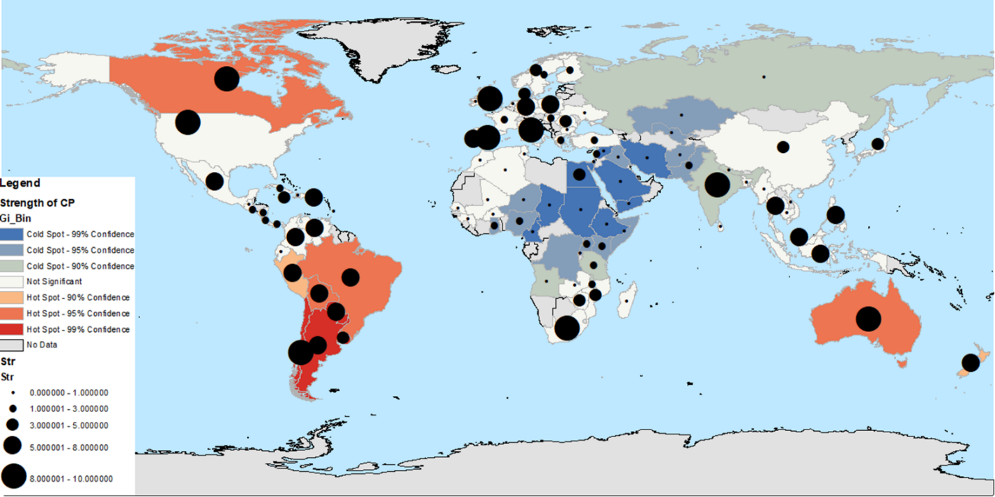
Figure 1. Hot spots analysis based on the Pearson’s correlation coefficient (R) for strength of community psychology across the world using Getis-Ord Gi* statistic. Significant hot spots of high values of CP are in red and significant hot spots of low values of CP are in blue. Black dots represent strength of community psychology.

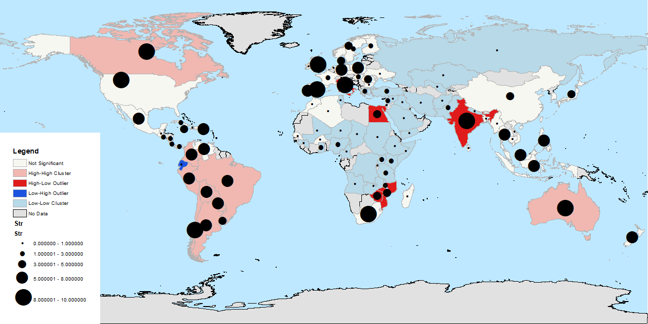

Figure 2. Cluster and Outlier analysis based on the Pearson’s correlation coefficient (R) for strength of community psychology across the world using Anselin Local Moran’s I statistic. Significant clusters of high values of strength are in light red and significant clusters of low values of strength are in light blue. Dark red represents the outlier countries having significantly higher strength than their neighbors; dark blue represents the outlier countries having significantly lower strength than their neighbors. Black dots represent strength of community psychology.

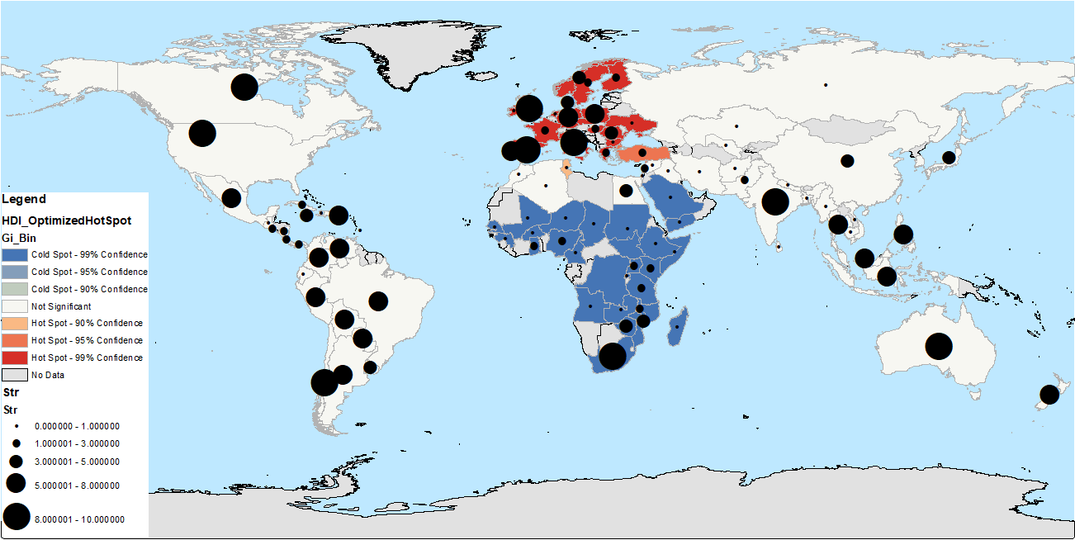
Figure 3. Hot spots analysis based on the Pearson’s correlation coefficient (R) for the HDI across the world using Getis-Ord Gi* statistic. Significant hot spots of high values of HDI are in red and significant hot spots of low values of HDI are in blue. Black dots represent the strength of community psychology.

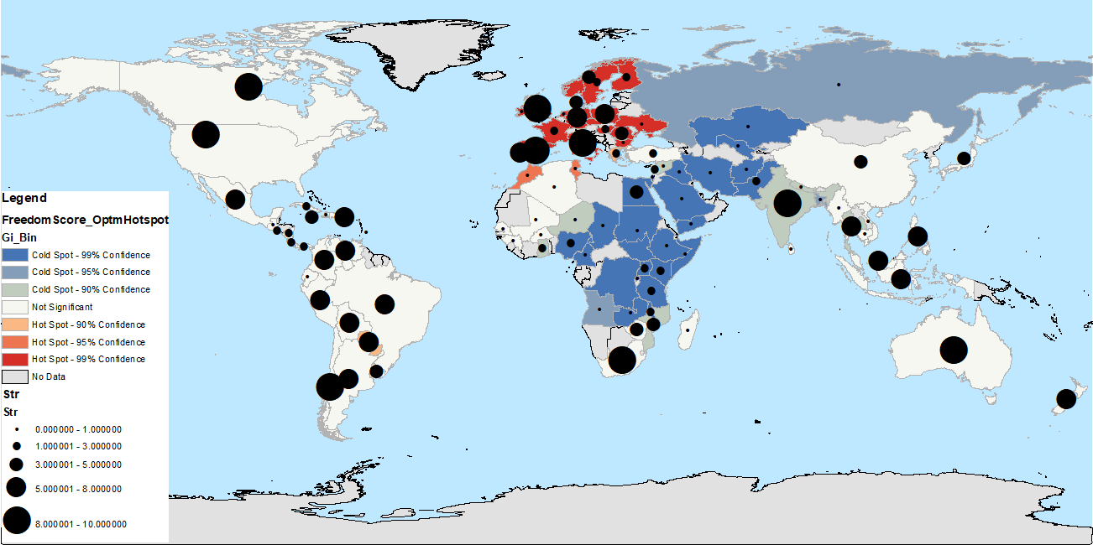
Figure 4. Hot spots analysis based on the Pearson’s correlation coefficient (R) for freedom score across the world using Getis-Ord Gi* statistic. Significant hot spots of high values of freedom score are in red and significant hot spots of low values of freedom score are in blue. Black dots represent the strength of community psychology.

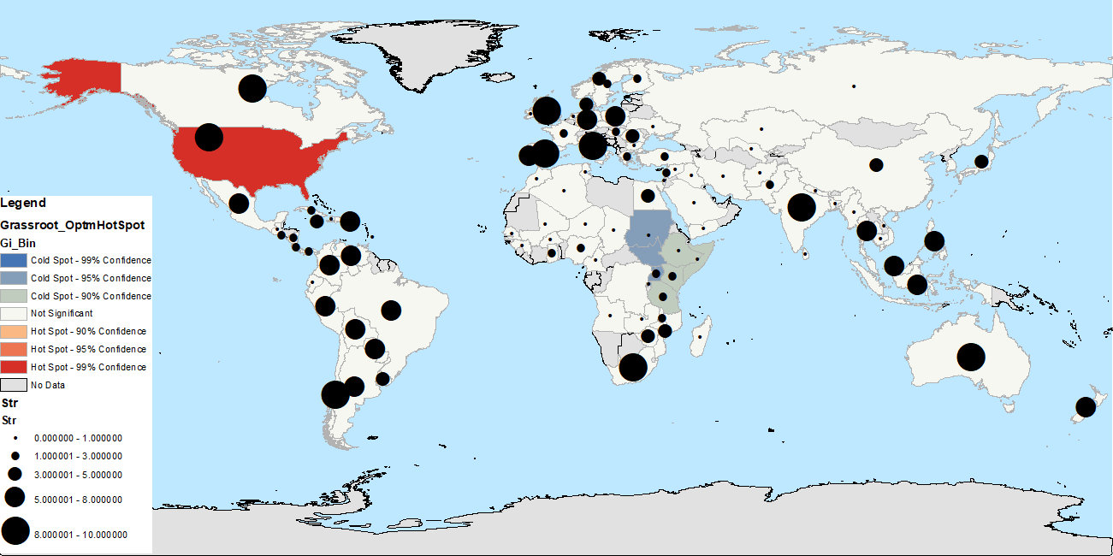
Figure 5. Hot spots analysis based on the Pearson’s correlation coefficient (R) for the activism across the world using Getis-Ord Gi* statistic. Significant hot spots of high values of activism are in red and significant hot spots of low values of activism are in blue. Black dots represent the strength of community psychology.

