Home HealthCare in the United States

Definition and Background

Home HealthCare is health care services that are given in the home for illnesses and injuries (“What’s home health care?”). The goal of home health care is for the patient to remain self-sufficient and independent while receiving the care that they need. It is primarily used to provide long term care and it is used in place of other health care initiatives (The Future of Home Health Care). Since the first general hospital was created in 1751 (Porter), home health care was the norm. “Home health care is actually the fastest growing Medicare program” (Welch, Wennberg, & Welch, 1996). It has grown at an annual rate of 20% since 1971 (Koren, 1986). Medicare is a government-run program established in 1965 to help provide insurance for citizens age 65 and older or citizens that have a severe disability. They were a part of President Lyndon B. Johnson’s vision of having a social commitment to acknowledging and meeting “individual social, economic, and healthcare needs” ("Differences between Medicare and Medicaid").

Home health care works by first, having the doctor determine if the patient needs home health care or would benefit from home health care. Once the doctor determines that, they must provide a list of agencies in the area to the patient and they must also let the patient know if they have any financial interest in any of the agencies on the list (“What’s home health care?”).

These agencies are in close contact with the primary care provider and hospitals in order to keep them up to date on the patient’s status (The Future of Home Health Care). The agencies establish relationships with caregivers and they also check to see if there are any concerns in the home. On top of providing independence, these agencies make sure to provide high-quality, patient centered care so that the patient can get the care that they need where they want.

Historical Context

Home health care was originally just a part of domestic life. Hospitals were only used as a last resort. The earliest official record of home health care not provided by family members was in 1813. It was thought to be a religious project of wealthy women from South Carolina. They went to the homes of the poor to provide care for them. There were 600 organizations that sponsored trained, visiting nurses through donations, subscriptions, fundraisers, and sometimes a paying patient by 1909. This increase in organizations was due to urbanization, immigration, and industrialization, which all contributed to an increase in illnesses. The increase of organizations due to these issues came from wealthy women in cities across the United States. They drew their inspiration from the South Carolina women in 1813. Due to the increase in chronic illnesses, home healthcare dropped off. This was because people were trying to figure out the best way to care for chronic illnesses while avoiding paying for long-term personal care. In the perspective of insurance companies, it was best to limit home health care for chronically ill patients (Buhler-Wilkerson, 2007).

Home healthcare was reinitiated into American lives by the 1950s due to the increase in long term care and increases in the cost of hospital care. The government and the American Medical Association studied home health care and pronounced home healthcare “a crucial and respected component in the continuum of care” (Buhler-Wilkerson, 2007). The first hospital based home health care program was established by Montefiore Hospital in New York City January 1st, 1947 (Buhler-Wilkerson, 2007). This was created because people felt that earlier home care by visiting nurses, not affiliated with a hospital, was “limited and lacking” (Buhler-Wilkerson, 2007). Policy makers called the program successful and it was seen as a hospital that was moving towards the future.
Medicare was created as part of the Social Security Act in 1965 and home health care was originally a part of Medicare, but it was restricted (Davitt & Choi, 2008). In the 1980s, the Omnibus Budget Reconciliation Act (OBRA) opened Medicare home health up to for-profit providers. After several policy changes, Medicare home health care use increased (Davitt & Choi, 2008).
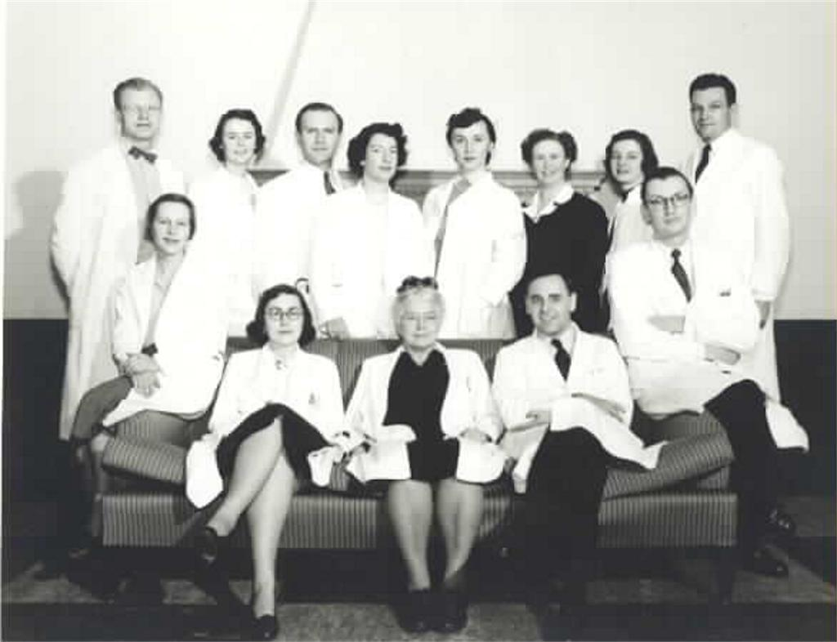
Figure 1. Faculty of the Medical Comprehensive Care and Teaching Program. The program, as part of the Cornell University Medical College, was used to teach fourth year students and offer home care to patients. They did not only take care of patients in the program, but also other patients with serious illnesses, chronic diseases, and terminal diseases. Murray Tar Inc.

Perspectives

It is said that doctors don’t really know of the services their patients are receiving from home health care agencies. One reason doctors may not know is because of Medicare. This is where it was recognized that the doctor would be key to utilization of home health care, but the doctor couldn’t be reimbursed for the function because of how time consuming it was, emotional exhaustion, and how there was really no incentive for the doctors (Koren, 1986).

Another reason could be due to the fact that there are different types of home health care agencies. Agencies could be for-profit, not-for-profit, community-based, government-sponsored, or hospital-based (Koren, 1986). Since there are so many different types, it would be difficult for the doctor to keep up with the type of care. Even though doctors initiate referrals, it is usually the home health agency staff that establish the frequency of visits and duration of placement (Koren, 1986). Doctors usually aren't aware of how many visits are there, how the agencies work and how much they cost. Although they don’t know any of these things, there really isn’t any incentive for them to learn because it isn't integral to medical practice.

It is important for them to know these things because they need to make sure the services are being implemented correctly. Patients can also sue the agencies and the doctors if they feel like they were discharged from the hospital prematurely (Koren, 1986).

Figure 2. A 30-year-old quadriplegic, Brent Kaderli, in a nursing home. He had to move to the nursing home because he required at least 6 hours of at home care while is father was at work and Medicaid approved him for only 3 hours to live “independently.” David Phillip.

Relation to Politics of Health

Similarly to home funerals and death with dignity, there is a certain autonomy to having health care provided at home. Health care was medicalized so that when people got sick, they were sent to the hospital. This is similar to funerals being held in funeral homes or people dying in hospitals. Historically, both of these events were taken care of in the home, like taking care of the sick was being taken care of in the home. With the increase in hospitals and the idea that hospitalization is needed, home health care dropped off. It became normal for people to send their sick loved ones to the hospital instead of taking care of them at home. Going back to home health care gives the patient autonomy to take care of their own health.

Works Cited

Buhler-Wilkerson, K. (2007). Care of the Chronically Ill at Home: An Unresolved Dilemma In Health Policy for the United States. The Milbank Quarterly, 85(4), 611-639. doi:10.1111/j.1468-0009.2007.00503.x

Davitt, J. K., & Choi, S. (2008). Tracing the History of Medicare Home Health Care: The Impact of Policy on Benefit Use. The Journal of Sociology and Social Welfare, 35(1), 247-276.

Differences between Medicare and Medicaid.” Medicare Interactive, www.medicareinteractive.org/get-answers/medicare-basics/medicare-coverage-overview/differences-between-medicare-and-medicaid

The Future of Home Health Care. (n.d), from https://www.livingwellah.com/pdf/160627_Harbingers_Infographic.pdf

Koren, M. J. (1986). Home Care- Who Cares? The New England Journal of Medicine, 314(14), 917-920. doi:10.1056/NEJM198604033141410

Murray Tarr Inc. (1952). Medical Comprehensive Care and Teaching Program. Faculty.. [gelatin silver print]. Retrieved from http://library.artstor.org/asset/SS34152_34152_11604599

Phillip, D. J. (2014, June 19). Home Care-15 Years Later [Digital image]. Retrieved from http://classic.apimages.com/OneUp.aspx?st=det&kw=home%20healthcare&ids=Home%20Care-15%20Years%20Later&showact=details&sort=relevance&intv=None&sh=14&kwstyle=and&adte=1518541289&pagez=20&cfasstyle=AND&rids=6e02ae415e814845aeaf3dd31a13587d&dbm=PY2014&page=1&xslt=1&mediatype=Photo#meta

Porter, R. (2004). Blood and guts: a short history of medicine. New York: Norton.

Welch, H. G., Wennberg, D. E., & Welch, W. P. (1996). The Use of Medicare Home Health Care Services. New England Journal of Medicine, 335(5), 324-329. doi:10.1056/nejm199608013350506

What's home health care? (n.d.). Retrieved February 13, 2018, from https://www.medicare.gov/what-medicare-covers/home-health-care/home-health-care-what-is-it-what-to-expect.html

