FAH holds international conference on intercultural philosophy 人文學院辦國際研討會探討跨文化哲學
In Event Recaps, News / April 16, 2015

An international conference titled ‘Transcendence and Immanence in Intercultural Philosophy’ was recently held at the University of Macau (UM). Co-organised by UM’s Philosophy and Religious Studies Programme, the conference explored various concepts and subfields of philosophy in an attempt to understand reality and answer fundamental questions about life, knowledge and wisdom.
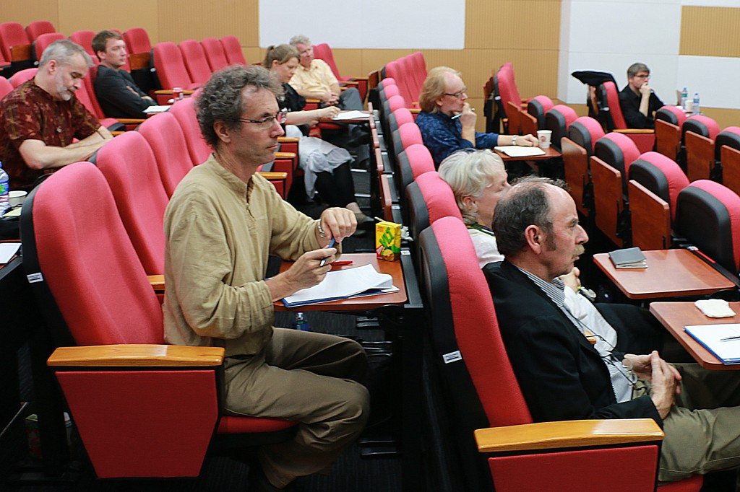
This conference brought together international scholars from a variety of philosophical, theological, and literary disciplines, including Roger T Ames from the University of Hawaiʻi at Mānoa in the United States; Fabian Heubel from the Academia Sinica in Taiwan; Hans-Rudolph Kantor from Huafan University in Taiwan; John W P Phillips from the National University of Singapore; Karl-Heinz Pohl from the University of Trier in Germany; and Antonia Pont from Deakin University in Australia, to discuss debates surrounding the themes of transcendence, immanence, and intercultural philosophy.
In the conference, UM professor William Franke pointed out that the theme of transcendence/immanence is especially controversial with respect to Chinese philosophy. The conference investigates whether the Chinese philosophy is primarily a philosophical discourse about immanence, and how the concepts of transcendence play a role in the tradition.
According to Prof Franke, Macao is a historical center at the interface between the two worlds of East and West, Asia and Europe. It is therefore a natural location for intercultural philosophy. The conference’s discussions on ‘What is Apophatic thinking and why is it relevant today’ and on ‘Transcendence and immanence in intercultural philosophy’ are apt examples to take place in Macao, which has served as the emblematic gateway for such exchange of ideas.
‘Intercultural philosophy is at an impasse over transcendence because it deals only with representations of transcendence, whereas what is really at stake in the question of transcendence is the unrepresentable. No representation of transcendence is appropriate to Chinese thought, and yet nothing is so important to this wisdom as what transcends representation,’ Franke argued.
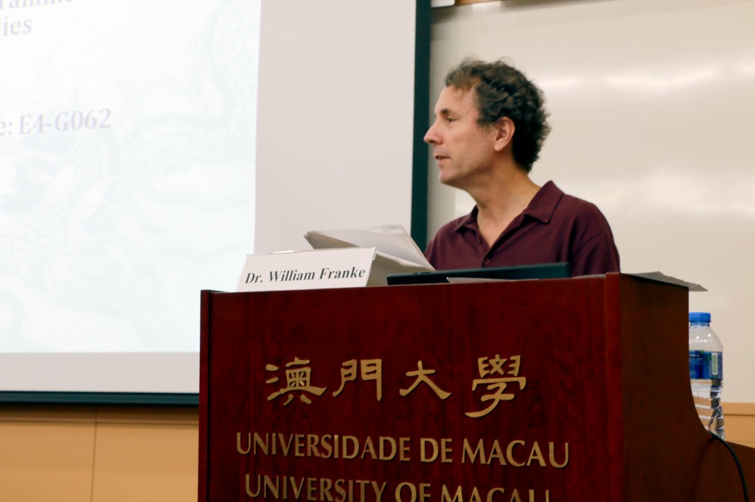
This conference attracted many international scholars, and their very diverse points of view made for a very lively and often surprising discussion that was sustained at maximum intensity over the two days. It was open to the public. The conference on apophatic thought even featured a session with prospective students questioning the purpose of philosophy. The conference is believed to strengthen academic relationships, which might lead to collaborations, co-authorships, and further conference events in the long run.
