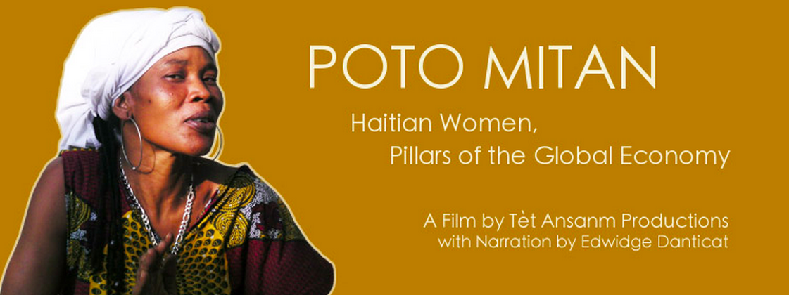

LESSON GUIDE

Through five Haitian women’s compelling lives, Poto Mitan gives an insider perspective on globalization, Haiti’s contemporary political/ economic crisis, and the resilient women challenging this system.

“Everyone else has spoken for Haitian women, yet, we have a history of speaking for ourselves. I support Poto Mitan because it offers us a rare glimpse into how Haitian women in the struggle understand their complex conditions and what they are doing for themselves.”
—Ulysse, Haitian-American scholar/activist/performer

Poto Mitan:
Haitian Women, Pillars of the Global Economy
Lesson Guide
Author: Ke Wang
Vanderbilt University, Center for Latin American Studies

Overview
Grade levels: 7th to 12th grade
Subject areas: Social studies (Economics, Geography, Human geography, Sociology)
Duration: 3 sessions, 50 minutes/session
Key words: Haiti, Globalization, Neoliberalism, Collective power, Women’s role and voice

In Poto Mitan, each of the five women’s personal story explains neoliberal globalization, how it is gendered, and how it impacts Haiti: inhumane working/ living conditions, violence, poverty, lack of education, and poor health care.

This lesson has been designed to use this 45-minute documentary Poto Mitan as a case study for in-depth discussion on:
- Globalization
- Indicators of economic development: GDP, Gini coefficient, CPI, inflation, etc.
- Economic concepts including but are not limited to: Reaganomics, Neoliberalism, and Structural Adjustment
- Individual-level, national-level, and international-level facts and policies about Haiti’s economy

Curriculum Contents/ Standards
Alabama Social Studies:
- Geography, 7th grade:
- Analyzing transnational relationships
- Explaining globalization and its impact on people in all regions of the world
- Human Geography, high school elective:
- Explain how economic interdependence and globalization impact many countries and their populations
- Interpret human geography as it relates to gender
- Sociology, high school elective:
- Explain methods and tools of research used by sociologists to study human society, including surveys, polls, statistics, demographic information, case studies, participant observations, and program evaluations.
- Identifying major ethical and social issues facing modern society
- Economics, 12th grade:
- Explain that a country’s standard of living depends upon its ability to produce goods and services
- Describe methods used to measure overall economic activity, including the Gross Domestic Product (GDP), the Consumer Price Index (CPI), inflation, and unemployment.
- Explain why individuals, businesses, and governments trade goods and participate in the global economy.
- Explain tariffs, quotas, embargoes, standards, and subsidies as trade barriers
- Explain why countries sometimes impose trade barriers and sometimes advocate free trade
Tennessee Social Studies:
- Economics, High school:
- E.56 Define trade barriers, such as quotas and tariffs
- E.57 Explain why countries sometimes erect barriers to trade such as quotas and tariffs, or through subsides to domestic producers and the consequences of those trade barriers and subsidies on consumers and producers. (E, G, H)
- E.60 Explain how changes in exchange rates impact the purchasing power of people in the United States and other countries. (E, G)
- Contemporary Issues, High school:
- CI.11 Identify and explain current crucial issues and the relevant groups and individuals involved in these issues in the United States and globally, including the creation of a media presentation that integrates multiple sources of information on one such issue. (C, E, G, H, P)
- Sociology, High school:
- S.35 Describe major social problems and social issues. (C, H)
- S.36 Analyze causes and effects of social problems and issues. (C, H)
- S.37 Construct possible solutions to given social problems and offer one solution in a presentation that integrates multiple sources of information from diverse formats and media. (C)

Materials
In-class: the students will need to be able to watch the documentary Poto Mitan, which is available through the lending library at Vanderbilt’s Center for Latin American Studies. The students will also need to have Internet access.
For teachers’ reference:
- Gapminder: an interactive map to show how the development indicators of countries change over time
- For more background information on and some free video clips of the documentary, please visit their main website at http://www.potomitan.net/
- Discussion Guide on Poto Mitan, authored by Mark Schuller: PDF accessible at http://www.potomitan.net/downloads/poto-mitan-study-guide.pdf

Lesson Plan

Day 1:
Activities | Time
Introduction  - Ask: what do you know about Haiti or the Caribbean?  - Share: have a few students share their knowledge  - Present: a map showing where Haiti and the Caribbean are  - Ask: what is globalization?  - Share: have a few students share how they interpret/ experience globalization  - Present: background information about the documentary Poto Mitan | 5-10 min
Screening  - All or part of Poto Mitan  - Ask students to make notes and pay special attention to:  - How the Haiti-U.S. relationship, or more broadly Haiti’s relationship to the world, influences Haitian people’s life  - Economic concepts that are new to them, e.g. Reaganomics, neoliberalism, structural adjustments, and the global assembly line | Max:  45 min
After-class:
- Assignment 1: Ask students to pick one new economic construct, gather information (definition and case study), and get prepared to share
- Group students based on the economic construct they’ve chosen for their assignment
- Assignment 2: Ask students to look up measures of Haiti’s economic development: GDP, Gini coefficient, CPI, inflation, unemployment, etc.

Day 2:
Activities | Time
Learn the Concepts- part 1, based on assignment 1  - Hand out to each student the glossary sheet of economic concepts (blank, this is to help students make notes), see appendix 1  - Ask students to sit in their respective economic construct groups; Reaganomics group, Neoliberalism group, Structural adjustment group, etc.  - Ask students to share their findings within their group and each group to 1) have an agreed-on explanation to their concept and 2) pick one elaborate case study illustrating how the concept has been adopted in real-life economic activities (national, corporate, or individual level)  - Groups will present and non-presenters will make notes | 25 min
Learn the Concepts- part 2, based on assignment 2  - Hand out to each student the glossary sheet of measures of economic development, see appendix 2  - Teacher presents and asks students to make notes on their glossary sheet: measures of Haiti’s economic development (GDP, Gini coefficient, CPI, inflation, unemployment; ask a few students to share what they’ve found through their Assignment 2)  - Gapminder activity: teacher uses Gapminder to illustrate the level of Haiti’s economic development as compared to U.S. and other countries; or if the students have access to Internet themselves, students can do this activity within their groups  - Ask students what other resources they know to look at development indicators of a country | 25 min

Day 3:
Activities | Time
Behind the Label  - In group, ask students to look at the tag on their own shirt (“Made in…”).  - Mark the countries of origin on a world map  - Gapminder activity: use Gapminder to look up (in group or as a class together) the development indicators of these countries  - Based on the information gathered from the Gapminder activity, ask students why factories are built in Haiti and in these countries, ask if this may differentially affect men and women in those countries. If so, why? | 15-20 min
Teacher synthesizing the pieces of information, with students’ contribution  - Based on students’ answer to the last question, review the concept of globalization  - Together with the students, fill in the chart attached at the end of this lesson plan (see appendix 3); specifically, the class will recall the stories in the documentary, and come up with individual-level, national-level, and international-level facts about Haiti. Ask students to discuss how different aspects of individual life are connected with each other; how the Haitian government’s policies and U.S. policies towards Haiti influence individual life, as presented in the documentary.  - Or: split students into groups and ask each group to draft an idea about one part of their daily lives they think might be linked to globalization. The instruction checks in with groups as they develop their ideas, and provides feedbacks and encouragement. Then, have the students jigsaw (mix groups so one member from each group is in each new group, and all ideas from the groups can be discussed). Have each member of the new jigsaw group share its group ideas.  - Follow up with a reflection activity, asking each student to write about one aspect of his/her daily life that is affected by globalization (homework, could be a blog entry). | 30 min

Appendix 1
Glossary of Economic Concepts

Concept | Definition | Case Study
Reaganomics
Neoliberalism
Structural Adjustment
…
…

Appendix 2
Glossary of Measures of Economic Development

Concept | Definition | Case Study
GDP
Gini coefficient
CPI
Inflation
Unemployment

Appendix 3
Facts about Haiti in Poto Mitan
(A rough layout of the chart; more information and arrows indicating the relationship between these components can be added)

